**Introduction to ASP.net**

**Web Applications**

* A *Web Application* consists of *web pages* that are generated in response to user requests.
* Some examples of web applications:
  + Search engines
  + Online stores
  + Auctions
  + News sites
  + Discussion groups
  + Games

**Web Form**

* A web page that contains controls that let the user interact with the page, like textboxes and drop-down lists, are called *web form.*
* An ASP.net application consists of one web form for each web application.

**Hardware and Software components of web applications**

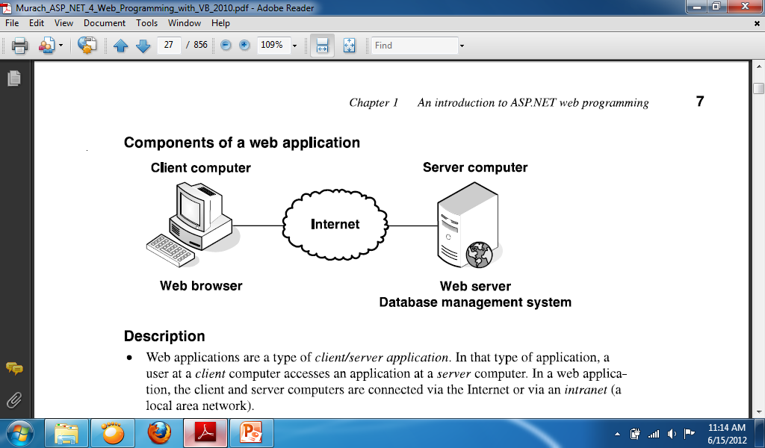

* Web applications are a type of *client / server* *application.*
  + In *client / server application* the function of the application are split between the *client* computer and *server* computer.
  + In a web application, the client and server computers are connected via internet or via *intranet* (a local area network).
* In a web application, the user works with a *web browser* at the client computer.
  + The *web browser* provides the user interface for the application.
  + The most common web browser is Microsoft’s Internet Explorer, but other web browsers like Mozilla Firefox and Chrome may be used.
* The application runs on the server computer under the control of *web server* software.
  + The web application itself is stored on the server computer. This computer runs *web server* software that enables it to send web pages to web browsers.
  + For ASP.net applications, the server typically runs Microsoft’s web server, called Internet Information Services, or IIS. Although *Apache* can also be used.
* The server computer also runs a *Database Management System or DBMS*, such as Microsoft SQL’s Server.
  + The DBMS provides access to information stored in a database.
  + To improve performance on larger applications, the DBMS can be run on a separate server computer.
* The user interface for a web application is implemented as a series of *web pages* that are displayed in the web browser.
* Each web page is defined by a *web form* using HTML, or HyperText Mark-up Language, which is a collection of mark-up tags.
* The web browser and web server exchange information using HTTP, or HyperText Transfer Protocol.

**Static web pages and Dynamic web pages**

**Static web page**

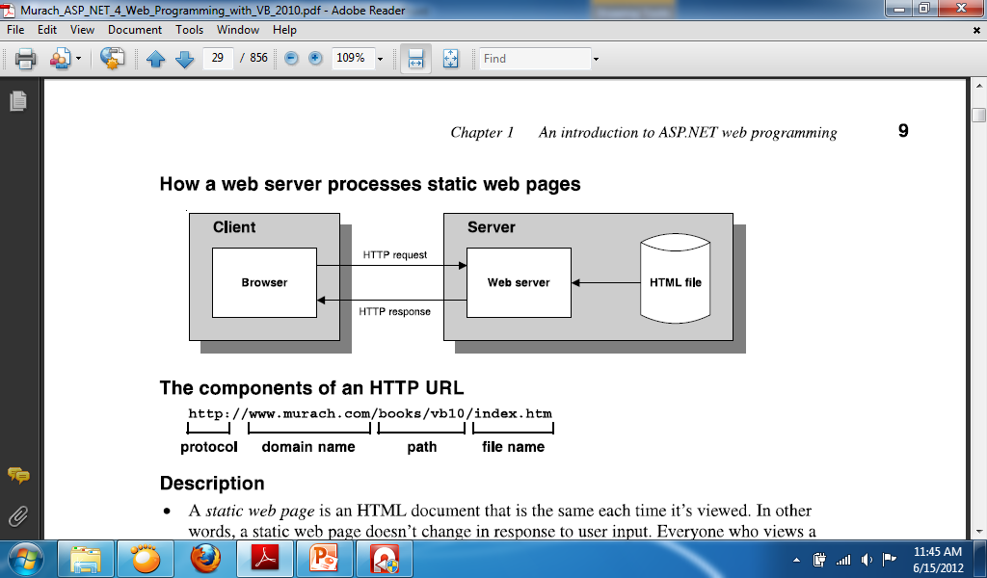

* A *static web page* is an HTML document that is the same each time it is viewed. In other words, a static web page doesn’t change in response to user input. Everyone who views a static web page sees exactly the same content.
* Static web pages are usually simple HTML files that are stored in the web server. When a browser requests a static web page, the web server retrieves the file from disk and sends it back to the browser. Static web pages usually have a file extension of .htm or .html.
* A web browser requests a page from a web server by sending the server an HTTP message known as an  *HTTP request.* The HTTP request includes the name of the HTML file being requested and the Internet addresses of both the browser and the web server.
* A user working with a browser can initiate an HTTP request in several ways.
  + One way is to type the address of a web page, called a *URL* (*Uniform Resource Locator)*, into the browser’s address and then press the enter key.
  + Another way is to click a link that refers to a web page.
* A web server replies to an HTTP request by sending a message known as an *HTTP response* back to the browser. The HTTP response contains the addresses of the browser and the server as well as the HTML document that’s being returned.

**Dynamic web page**

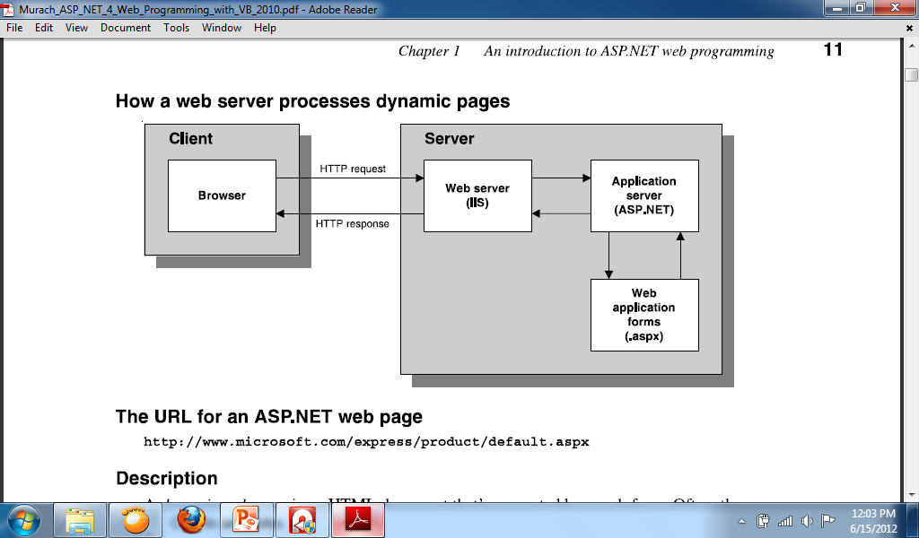

* When a web server receives a request for a dynamic web page, it looks up the extension of the requested file in a list of *application mappings* to find out which application server should process the request. If the file extension is aspx, the request is passed on to ASP.net for processing.
  + Application mappings indicate what program a file extension is associated with.
* When the *application server* receives a request, it runs the specified web form. Then the web form generates an HTML document and returns it to the application server, which passes it back to the web server and from there to the browser.
* The browser doesn’t know or care whether the HTML was retrieved from a static HTML file or generated dynamically by a web form. Either way, the browser simply displays the HTML that was returned as a result of the request.
* After the page is displayed, the user can interact with it using its controls. Some of those controls let the user *post* the page *back* to the server, which is called a *postback.* Then, the page is processed again using the data the user entered.
* The process that begins with the user requesting a web page and ends with the server sending a response back to the client is called a *round trip.*

**What is state?**

* *State* refers to the current status of the properties, variables, and other data maintained by an application for a single user. The application must maintain a separate state for each user currently accessing the application.
* HTTP is a *statless protocol.* That means that it doesn’t keep track of state between roundtrips. Once a browser makes a request and receives a response, the application terminates and its state is lost.

**Four ASP.net features for maintaining state:**

* View state:
  + ASP.net uses *view state* to maintain the value of form control properties that the application changes between executions of the application. Since view state is implemented by default, no special coding is required.
* Session state:
  + When a user starts a new session, ASP.net creates a *session state* *object* that contains a *session ID.* This ID is passed from the server to the browser and back to the server so the server can associate the browser with an existing session. To maintain *session state*, you can add program values to the session state object.
* Application state:
  + When an application begins, ASP.net creates an *application state object*. To maintain *application state,* you can add program values to the application state object. These values are available to all users of the application until the application ends.
* Profile:
  + You can use the *profile* feature to keep track of user data. Although a profile is similar to a session state object, it persists between user sessions because it is stored in a database. The profile feature is not commonly used.

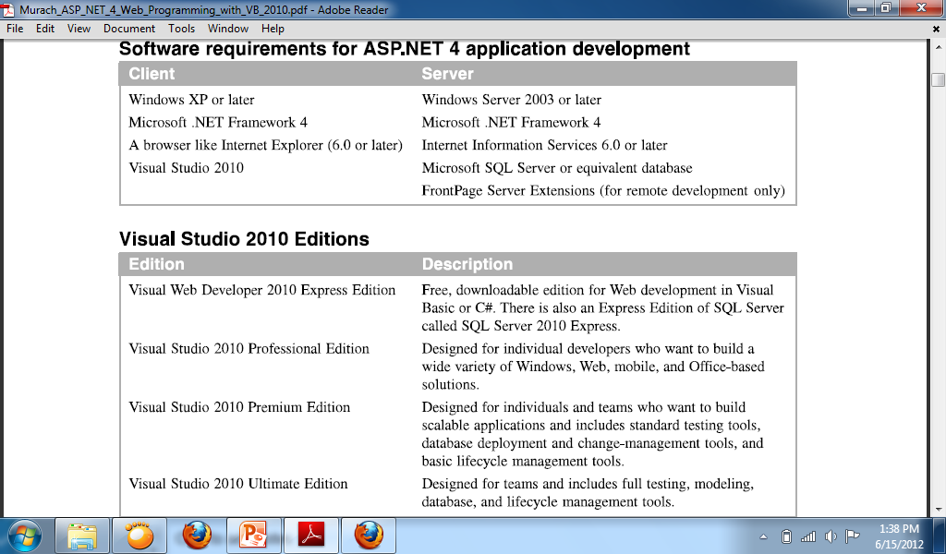

**Three environments for developing ASP.net applications**

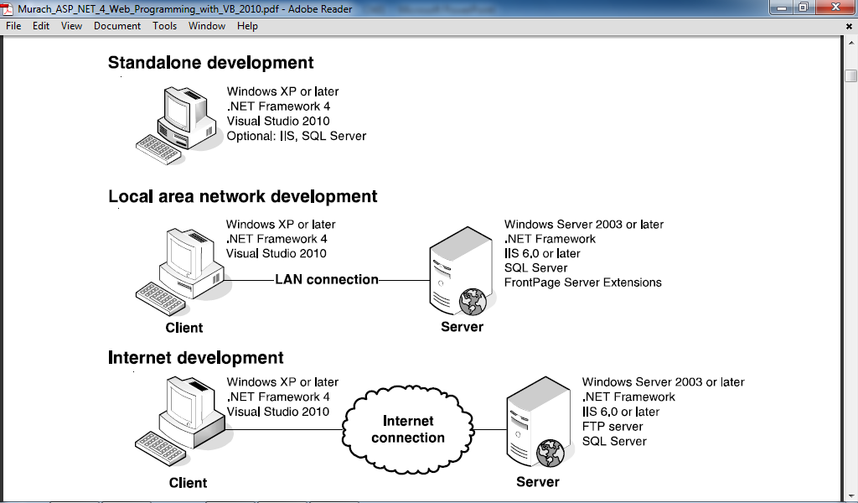

* Standalone development:
  + When you use standalone development, a single computer serves as both the client and the server.
* Local area network development:
  + When you use a *local area network* (LAN), a client computer communicates with a server computer over the LAN. With this setup, two or more programmers at the same site can work on the same application.
* Internet development:
  + When you use Internet development, a client computer communicates with a server computer over the internet. With this setup, programmers at different locations can work on the same application

**More about ASP.net**

* For each web form in an application, ASP.net 4 keeps two files. The file with the aspx extension holds the HTML code and the ASP tags for the server controls. The file with the aspx.vb extension is the *code-behind file* that contains the Visual Basic code for the form.

**Introduction to the VS 2010 IDE**

* The Visual Studio 2010 Integrated Development Environment (IDE) provides the interface for developing various kinds of applications. The IDE is a centralized location for developing these applications or components of applications as projects.

**Basic windows of VS 2010 IDE**

* Start Page
* Toolbars
* Solution Explorer Window
* Properties Window
* Code Editor
* Design View
* Source View
* IntelliSense

**Start Page**

* The *Start Page* is the default page of Visual Studio 2010.
* The *Start Page* displays the following panes:
  + *Recent Projects:* This pane displays a list of the most recent projects you opened with Visual Studio. You can open the projects by clicking on the hyperlink having the project’s name.
  + *Getting Started:* This pane contains links to various programming tasks in the product’s documentation.

**Toolbars**

* The *Toolbars* in the .NET IDE provides developers with an easy access to the features of the IDE. The .NET IDE provides different toolbars for each category of tasks that are needed in the process of developing an application. The *Standard Toolbar* is the default visible toolbar.

**Solution Explorer**

* The *Solution Explorer* window lists the solution name, the project name, and all the forms and modules that are used in the project.
* The *Solution Explorer* window is viewed in either of the following ways:
  + From the main menu, select View > Solution Explorer
  + Press the key combination CTRL+ALT+L

**Properties Window**

* The Visual Studio IDE makes the task of designing a user interface for Windows and Web applications very easy providing the *Properties* window.
* The properties of Windows Forms or Web Forms and the controls on the forms can be set interactively at the application design time by using this window.
* The buttons on the toolbar of the Properties window allow for sorting of properties in alphabetical order or category-wise navigation of properties and events.
* The *Properties* window is viewed in either of the following ways:
  + From the main menu, select View > Properties Windows.
  + Press the F4 key.

**Code Editor**

* The Visual Studio IDE provides with a built-in and very advanced editor for writing code for the .NET projects. This supports the keywords and identifiers of the Visual Studio environment. If Visual Basic is chosen as the programming language for a .NET project, then the Code Editor for this project only supports Visual Basic syntax and not those of any other .NET programming language.
* The Code Editor recognizes keywords and identifiers of the programming language in use and applies proper color-coding schemes and layout indenting to them. It checks and warns the developer for the syntax errors, incorrect initialization of variables, invalid declarations, and unrecognized calling of procedures by appropriately highlighting them.

**Design View**

* The Design View of Visual Studio 2010 allows a developer to design a user-friendly and a customized Web Form.
* In the Design View, you can perfectly align the Web controls on a Web Form and set the graphical properties of these controls.
* The Design View offers a lot of customization and formatting features for the Web Forms, some of which are as follows:
  + You can directly write text on the Web Form.
  + You can customize the layout of the Web Forms as absolute and relative using position option in the format menu.
  + You can apply various font styles, foreground. And background colors on the Web Form and the controls contained in it.

**Source View**

* You can access the Source View of a Web page by clicking the source tab present at the bottom of the Visual Studio IDE.
* This view contains the HTML definition of the Web Form and all the controls present to it.
* If you drag and drop a control on the Web Form either in the Design view or in the Source view, you see that their equivalent HTML tags are induced into the Source View.
* Also as you go on customizing a control’s appearance by setting different properties through the Properties window, these are reflected in the HTML tag for that control in the Design view.

**IntelliSense**

* Visual Studio Code Editor supports the feature of *IntelliSense,* which helps you to write accurate code. As you start typing the code the methods, properties, and events of the .NET Framework Class Library are automatically offered as a sorted list with the help of IntelliSense feature. This list, which automatically opens in an IntelliSense, shows all the members that are valid for using the code.
* When the Web developer selects an option from the IntelliSense, it is included in the line of code with accurate spelling and case.
* While writing a code, if there is any error in the code, the IntelliSense underline the code or the keyword that signifies an induced error.

**Creating Websites in ASP.Net**

**Web site**

* In Visual Studio 2010, a web application is called a *web site*.
* A *web project* is a project that is used for the development of a web site. Web sites are often referred to as web projects. However, ASP.Net web sites don’t use project files. Instead, they use web.config files to store project information.
* To create a new ASP.Net web application, use the *File > New Web Site* command.
* When you start a new web site, Visual Studio creates a solution file for the web site in the default location for solution files, which is normally My Documents \ Visual Studio 2010 \ Projects.

**New web site dialog box**

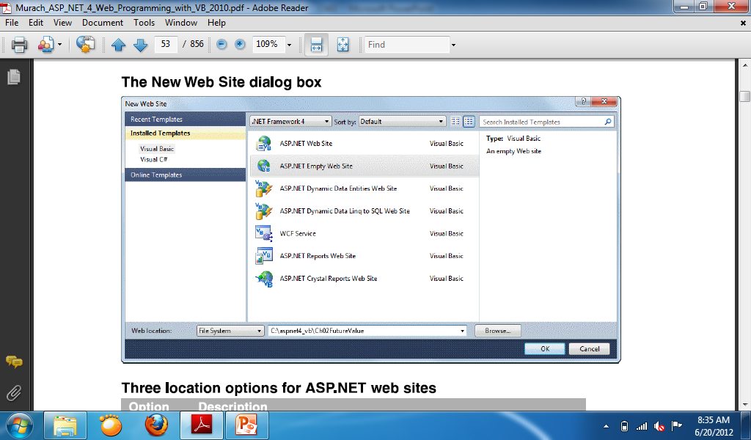

**Three location options for ASP.NET web sites**

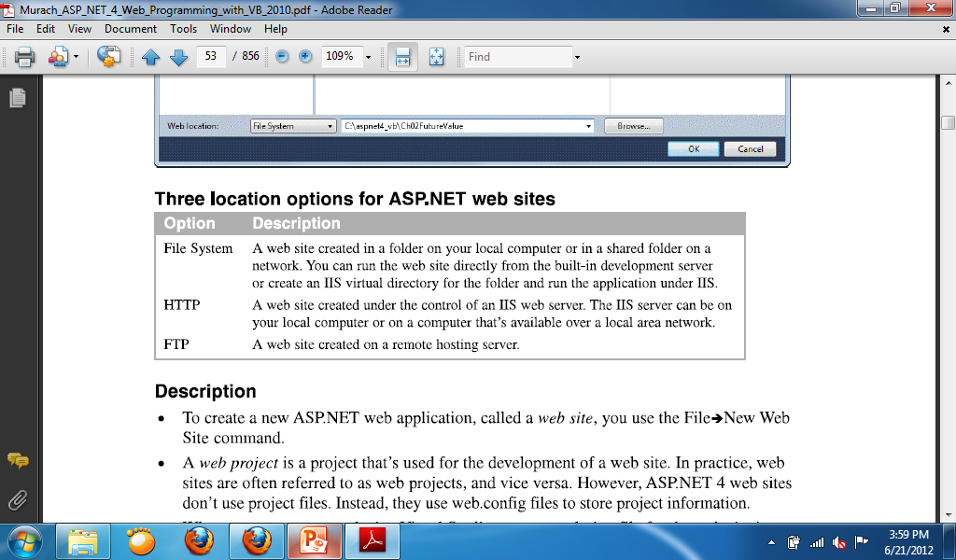

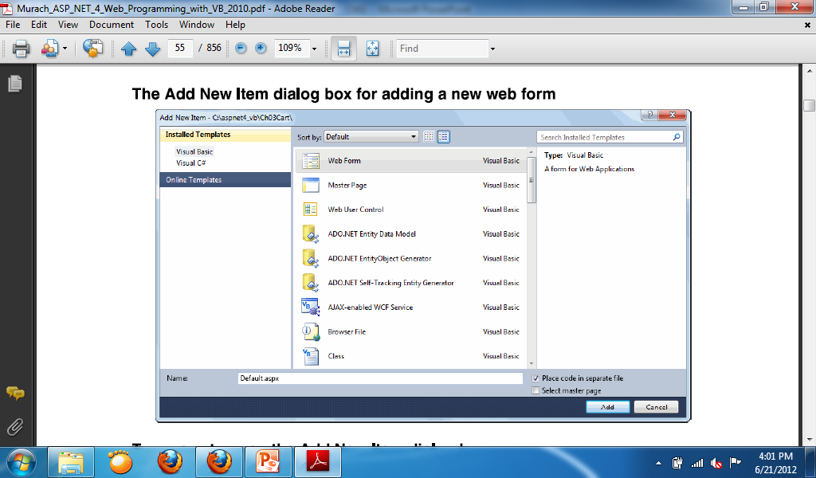

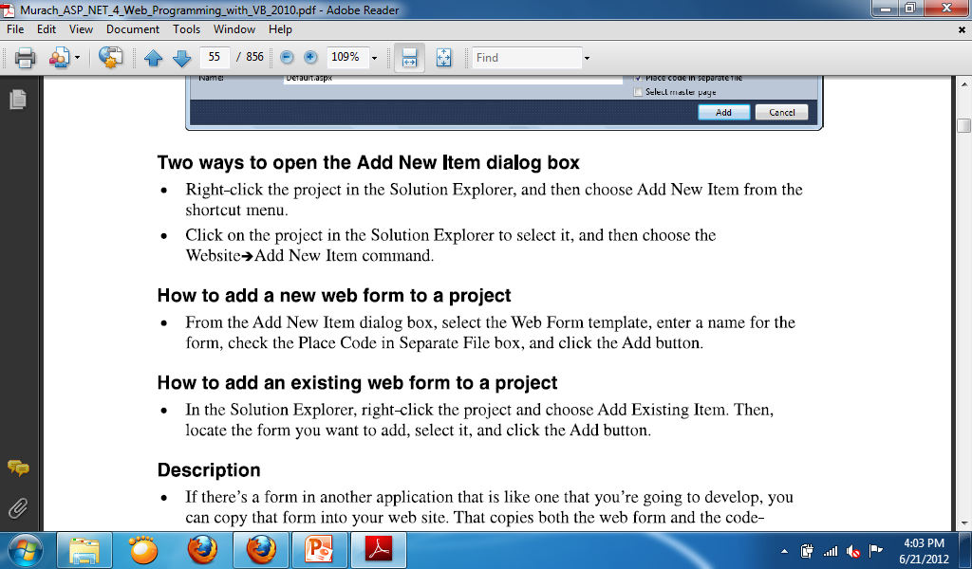

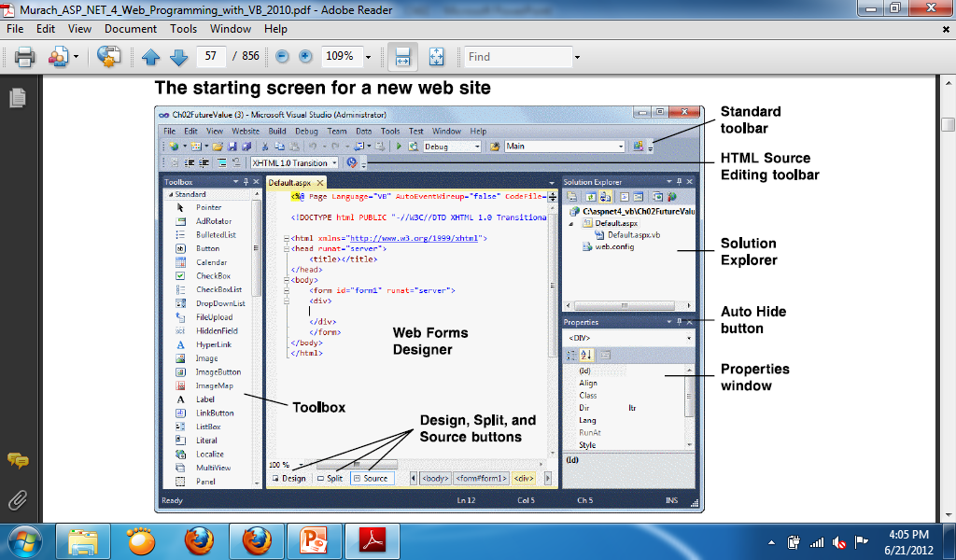

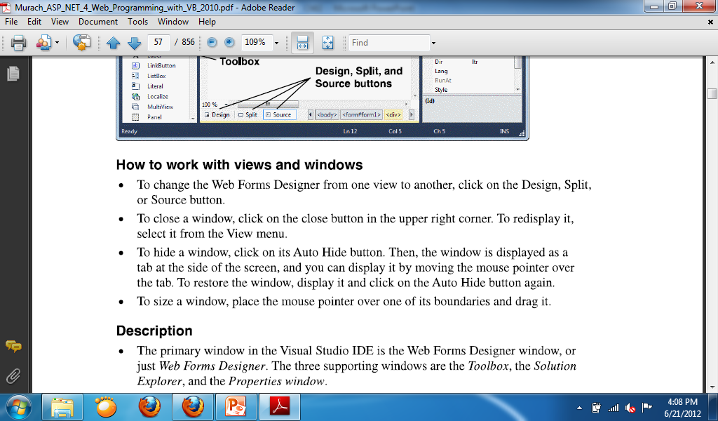

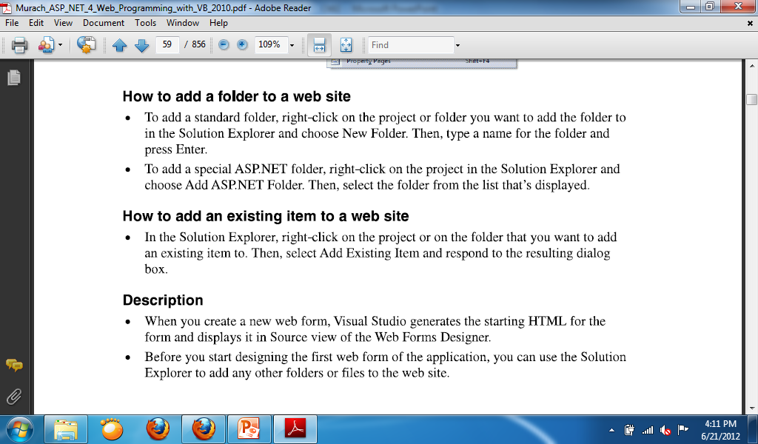

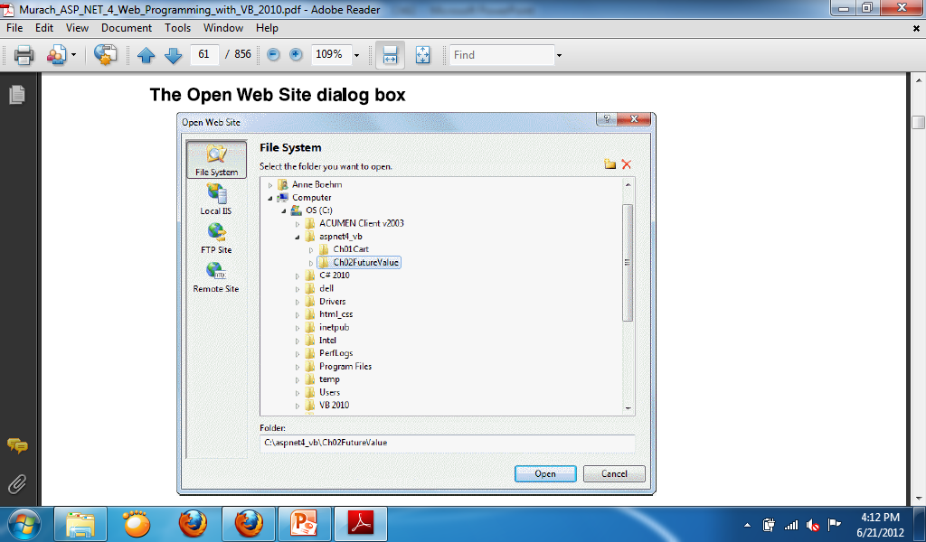

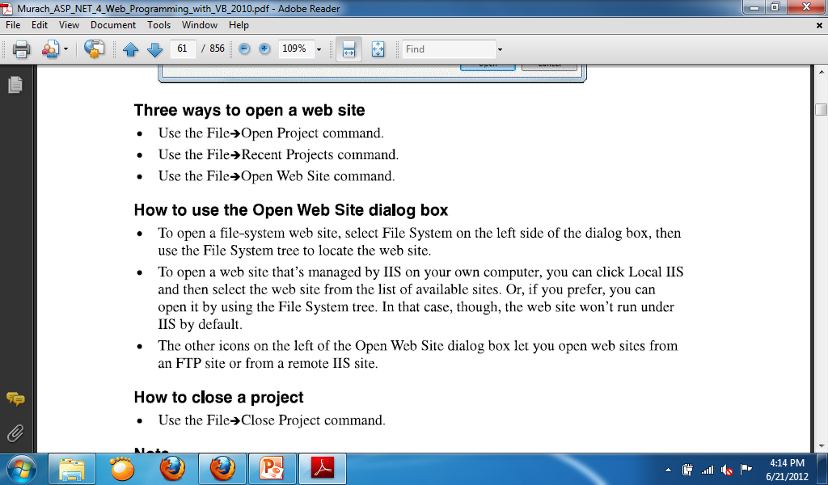

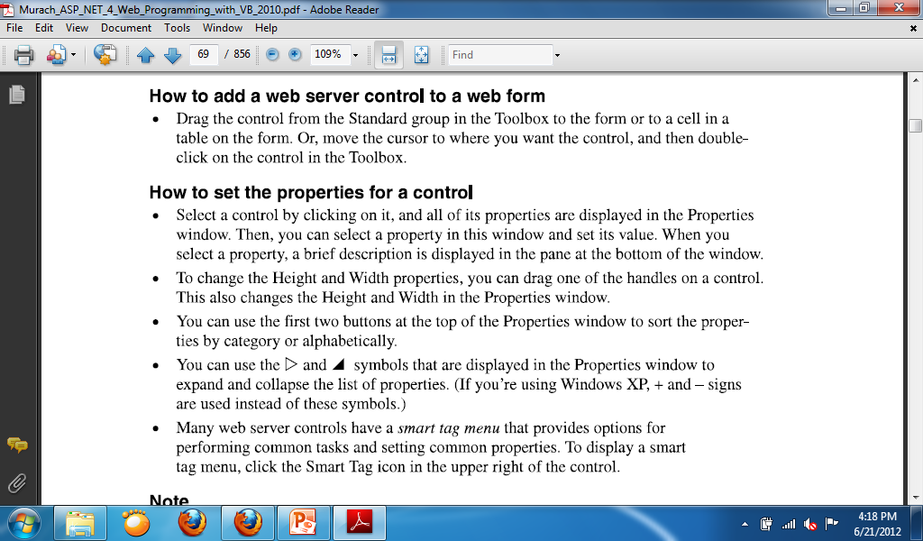

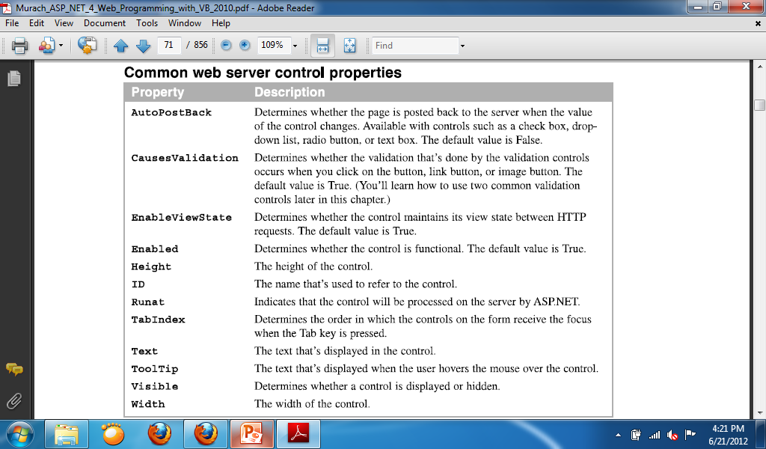

**How to use Source View to modify the design**

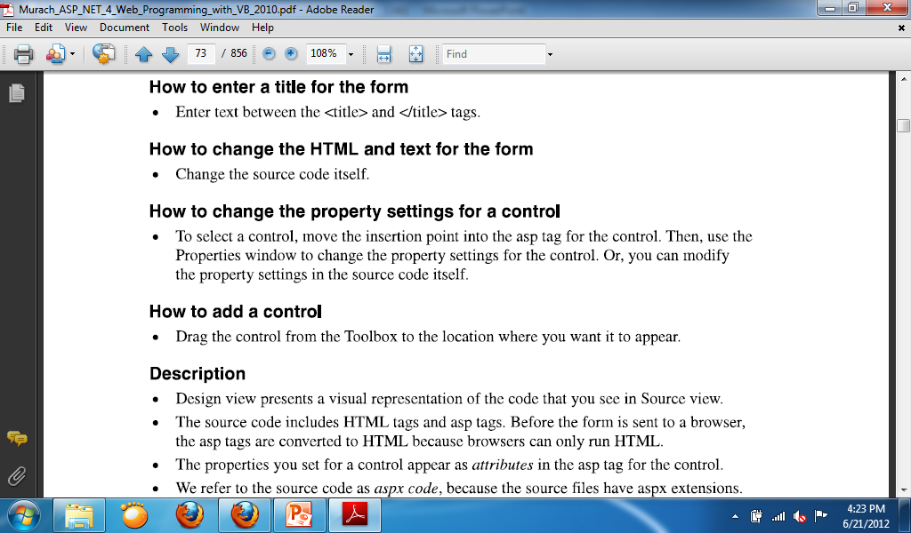

**Modify the form design using Split View**

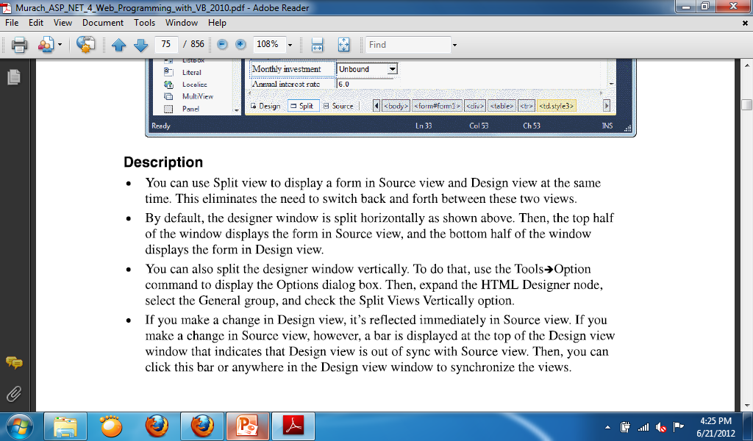

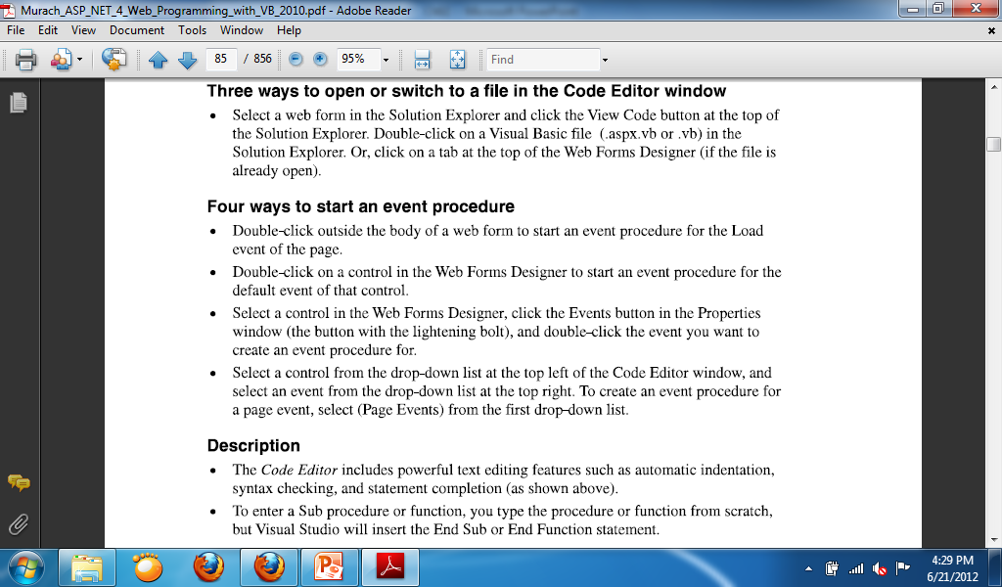

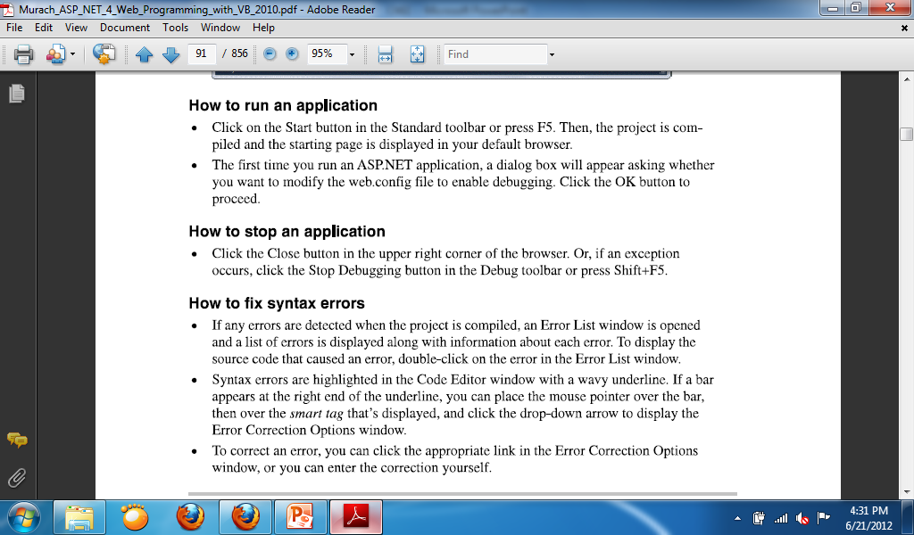

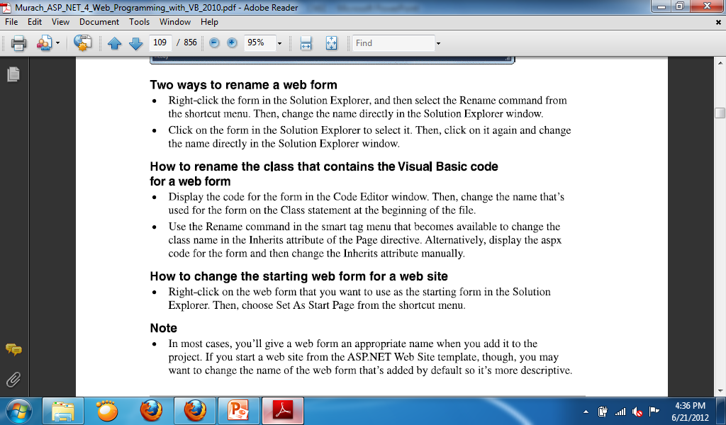

**How to redirect or transfer to another page**

* Response.Redirect(“Cart.aspx”)

or

* Response.Redirect(“http://www.google.com/”)

**ASP.Net Controls**

**Standard Controls**

**Using the Label Control**

* Whenever you need to modify the text displayed in a page dynamically, you can use the Label control.
* Common Properties:
  + **BackColor**—Enables you to change the background color of the label.
  + **BorderColor**—Enables you to set the color of a border rendered around the label.
  + **BorderStyle**—Enables you to display a border around the label. Possible values are NotSet, None, Dotted, Dashed, Solid, Double, Groove, Ridge, Inset, and Outset.
  + **BorderWidth**—Enables you to set the size of a border rendered around the label.
  + **CssClass**—Enables you to associate a Cascading Style Sheet class with the label.
  + **Font**—Enables you to set the label’s font properties.
  + **ForeColor**—Enables you to set the color of the content rendered by the label.
  + **Style**—Enables you to assign style attributes to the label.
  + **ToolTip**—Enables you to set a label’s title attribute. (In Microsoft Internet Explorer, the title attribute displays as a floating tooltip.)

**Showing time using Label Control**

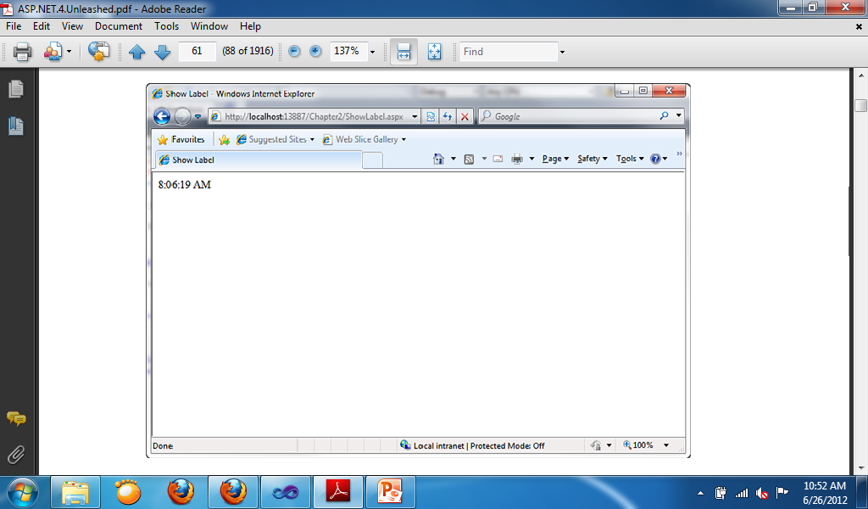

Protected Sub Page_Load(ByVal sender As Object, ByVal e As System.EventArgs) Handles Me.Load

Label1.Text = TimeOfDay

End Sub

**Accepting User Input**

* The ASP.NET Framework includes several controls that you can use to gather user input. In this section, you learn how to use the TextBox, CheckBox, and RadioButton controls. These controls correspond to the standard types of HTML input tags.

**Using the TextBox Control**

* You can use the TextBox control to display three different types of input fields depending on the value of its TextMode property.
* The TextMode property accepts the following three values:
  + **SingleLine**—Displays a single-line input field.
  + **MultiLine**—Displays a multiline input field.
  + **Password**—Displays a single-line input field in which the text is hidden.

**TextBox Properties, Methods and Events**

* **Properties:**
  + **Enabled**—Enables you to disable the text box.
  + **MaxLength**—Enables you to specify the maximum length of data that a user can enter in a text box. (This does not work when TextMode is set to Multiline.)
  + **ReadOnly**—Enables you to prevent users from changing the text in a text box.
  + **Rows**—Enables you to specify the number of rows to display.
  + **TabIndex**—Enables you to specify the tab order of the text box.
  + **Wrap**—Enables you to specify whether text word-wraps when the TextMode is set toMultiline.
* **Method:**
  + **Focus**—Enables you to set the initial form focus to the text box.
* **Event:**
  + **TextChanged**—Raised on the server when the contents of the text box are changed.

**Sample for TextBox TextChanged event**

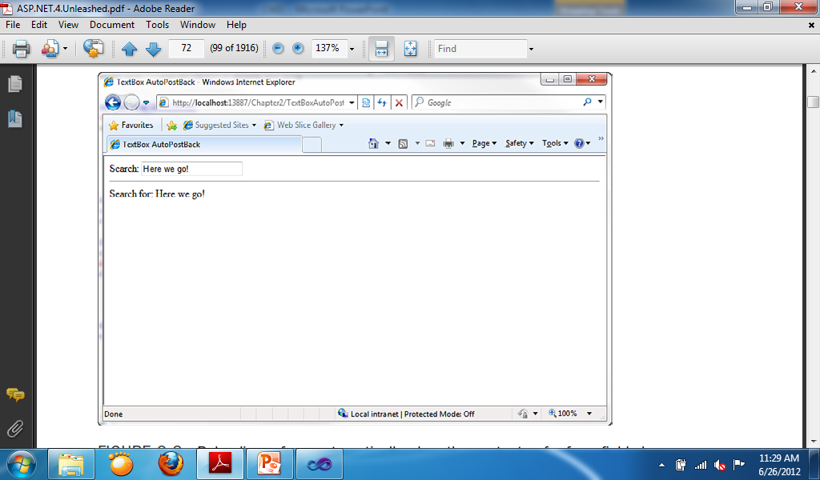

Protected Sub TextBox1_TextChanged(ByVal sender As Object, ByVal e As System.EventArgs) Handles TextBox1.TextChanged

Label2.Text = "Search for: " + TextBox1.Text

End Sub

**Using the CheckBox Control**

* The CheckBox control enables you to display a check box.
* CheckBox enables you to select or deselect multiple options in a group of CheckBoxes.
* When the CheckBox have a check mark, it means it is selected, when the CheckBox doesn’t have a check mark it is deselected.
* You can check / select mulitple CheckBoxes at the same time.

**CheckBox Properties, Methods and Events**

* **Properties:**
  + **Checked**—Enables you to get or set whether the CheckBox is checked.
  + **Enabled**—Enables you to disable the TextBox.
  + **TabIndex**—Enables you to specify the tab order of the check box.
  + **Text**—Enables you to provide a label for the check box.
  + **TextAlign**—Enables you to align the label for the check box. Possible values are Left and Right.
* **Methods:**
  + **Focus**—Enables you to set the initial form focus to the check box.
* **Event:**
  + **CheckedChanged**—Raised on the server when the check box is checked or unchecked.

**Displaying checkbox**

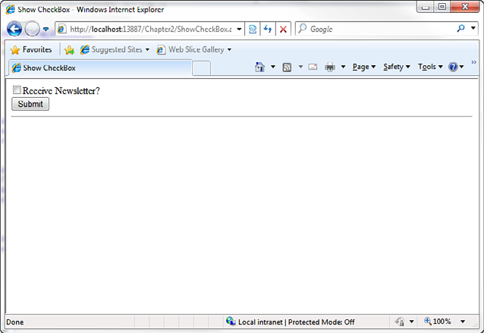

Protected Sub Button1_Click(ByVal sender As Object, ByVal e As EventArgs) Handles Button1.Click

Label1.Text = CheckBox1.Checked.ToString

End Sub

**Using the RadioButton Control**

* You always use the RadioButton control in a group. Only one radio button in a group of RadioButton controls can be checked at a time.

**RadioButton Properties, Methods and Events**

* **Properties:**
  + **Checked**—Enables you to get or set whether th RadioButton control is checked.
  + **Enabled**—Enables you to disable the RadioButton.
  + **GroupName**—Enables you to group RadioButton controls.
  + **TabIndex**—Enables you to specify the tab order of the RadioButton control.
  + **Text**—Enables you to label the RadioButton control.
  + **TextAlign**—Enables you to align the RadioButton label. Possible values are Left and Right.
* **Methods:**
  + Focus—Enables you to set the initial form focus to the RadioButton control.
* **Events:**
  + CheckedChanged—Raised on the server when the RadioButton is checked or unchecked.

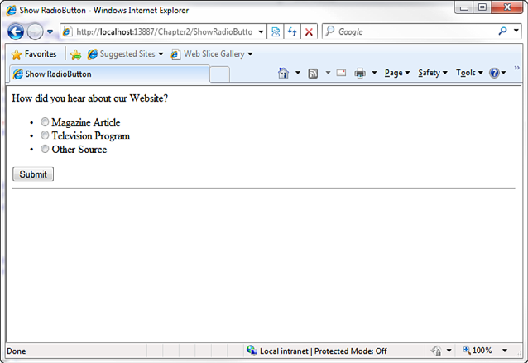

* Change the GroupName property of the RadioButtons First

Protected Sub Button1_Click(ByVal sender As Object, ByVal e As EventArgs) Handles Button1.Click

If RadioButton1.Checked = True Then

Label1.Text = RadioButton1.Text

ElseIf RadioButton2.Checked = True Then

Label1.Text = RadioButton2.Text

ElseIf RadioButton3.Checked = True Then

Label1.Text = RadioButton3.Text

End If

End Sub

**Submitting Form Data**

**Using the Button, LinkButton and ImageButton Control**

* The Button control renders a push button that you can use to submit a form to the server.
* The Button control is often the location where you can find most of the codes.
* The three buttons have the same function but the link button looks like a hyperlink and the image button is a picture.

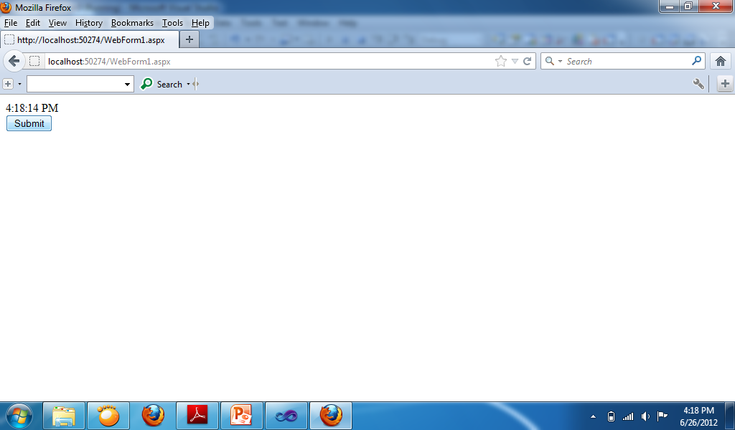

Protected Sub Button1_Click(ByVal sender As Object, ByVal e As EventArgs) Handles Button1.Click

Label1.Text = TimeOfDay

End Sub

**Displaying Images**

**Using the Image Control**

* The control in ASP.Net used in displaying images.

**Container Controls**

**Using the Panel Control**

* The Panel control enables you to work with a group of ASP.NET controls.
* For example, you can use a Panel control to hide or show a group of ASP.NET controls.
* Common Property for Panel is **GroupingText**—Enables you to render the Panel control as a fieldset with a particular legend.

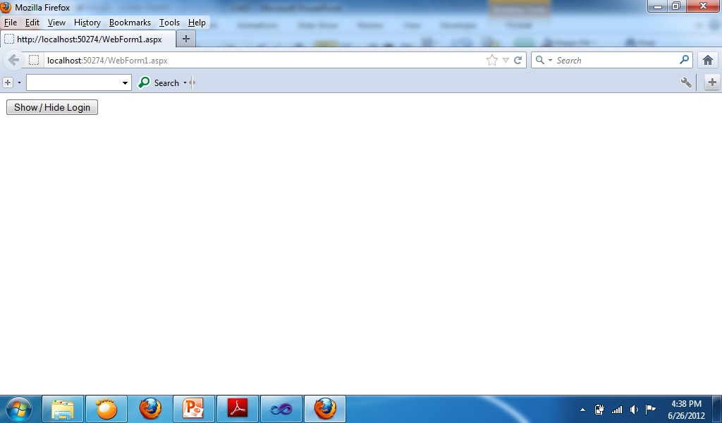 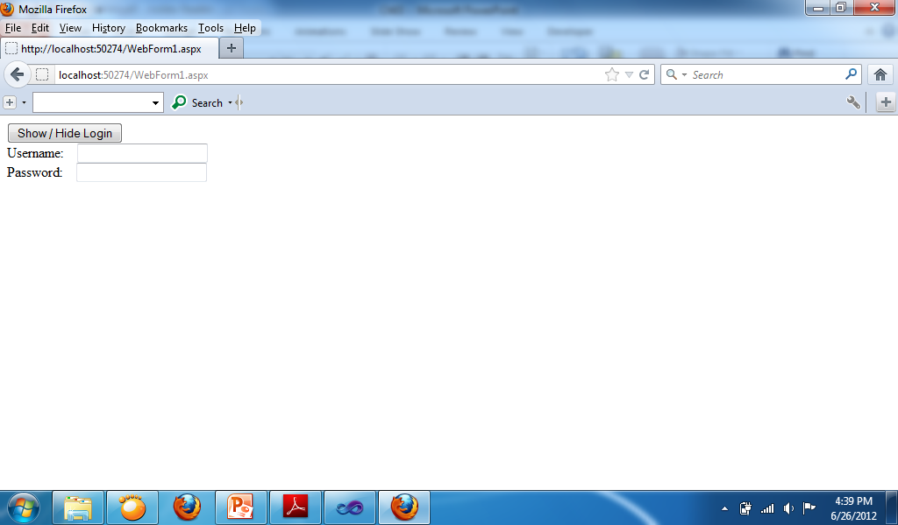

* Change the Visible property of the Panel to False first.

Protected Sub Button1_Click(ByVal sender As Object, ByVal e As EventArgs) Handles Button1.Click

If Panel1.Visible = True Then

Panel1.Visible = False

Else

Panel1.Visible = True

End If

End Sub

**Validation Controls**

**Overview of Validation controls**

* Common Validation controls in ASP.Net:
  + **RequiredFieldValidator**—Enables you to require a user to enter a value in a form field.
  + **RangeValidator**—Enables you to check whether a value falls between a certain minimum and maximum value.
  + **CompareValidator**—Enables you to compare a value against another value or perform a data type check.
  + **RegularExpressionValidator**—Enables you to compare a value against a regular expression.
  + **ValidationSummary**—Enables you to display a summary of all validation errors in a page.
* You can associate the validation controls with any form controls included in ASP.NET Framework. For example, if you want to require a user to enter a value into a TextBox control, you can associate a RequiredFieldValidator control with the TextBox control.
* You should always check the Page.IsValid property when working with data submitted with a form that contains validation controls. Each of the validation controls includes an IsValid property that returns the value True when a validation error doesn’t exist. The Page.IsValid property returns the value True when the IsValid property for of the validation controls in a page returns the value True.
* It is easy to forget to check the Page.IsValid property. When you use a browser that supports JavaScript with the validation controls, you are prevented from submitting a form back to the server when validation errors exist. However, if someone requests a page using a browser that does not support JavaScript, the page is submitted back to the server even when validation errors exist.

**RequiredFieldValidator Control**

* The RequiredFieldValidator control enables you to require a user to enter a value into a form field before submitting the form.
* You must set two important properties when using the RequiredFieldValidator control:
  + **ControlToValidate**—The ID of the form field validated.
  + **ErrorMessage**—The error message displayed when validation fails.
* By default, the RequiredFieldValidator checks for a nonempty string (spaces don’t count). If you enter anything into the form field associated with the RequiredFieldValidator, the RequiredFieldValidator does not display its validation error message.

**Sample for Required Field Validator Text property**

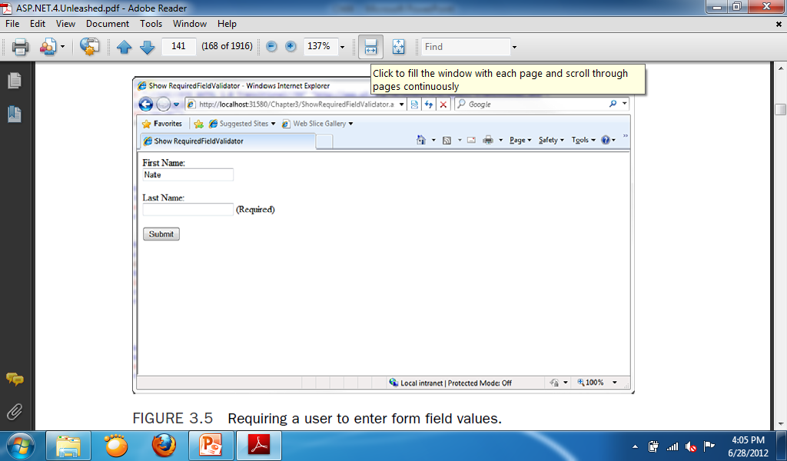

* Insert 2 RequiredFieldValidator on the web form.
* Change the **ControlToValidate** property of the 2 RequiredFieldValidator to the 2 TextBoxes.
* Change the **ErrorMessage** property of the 2 RequiredFieldValidator to (Required).
* Code for button:

If IsValid Then

Response.Redirect("Webform2.aspx")

End If

**Sample for RequiredFieldValidator Initial Value Property**

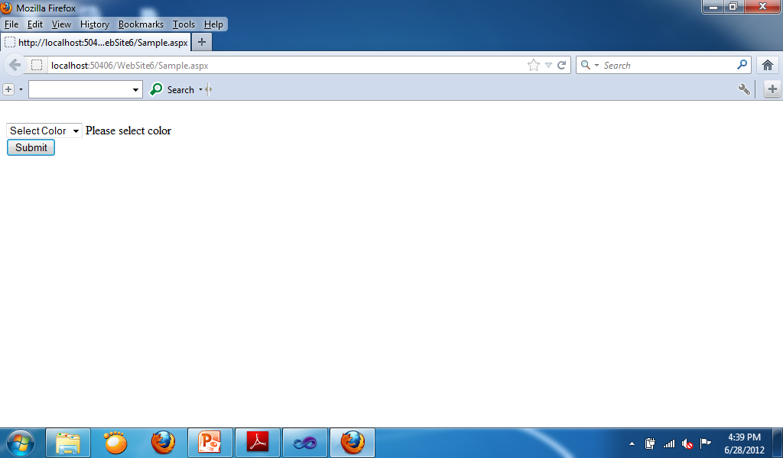 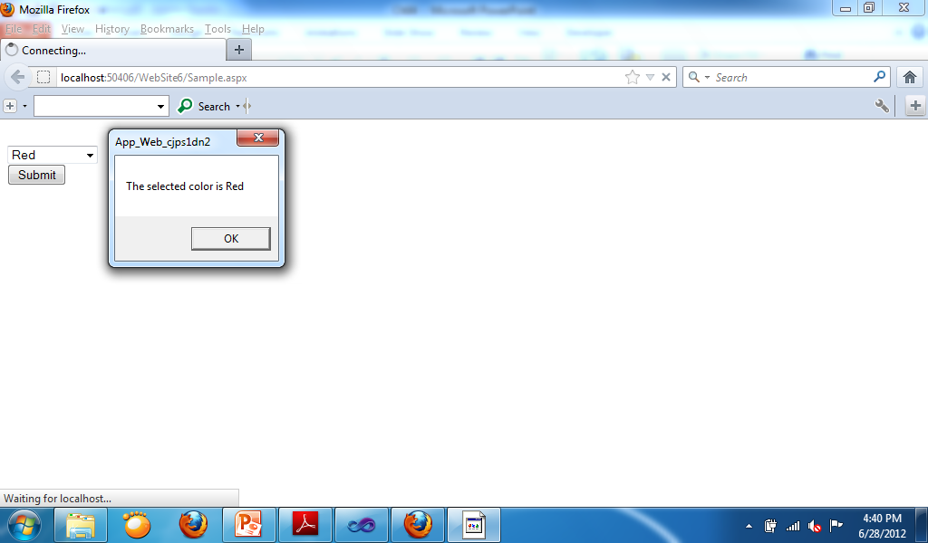

* Insert a Drop-down List, a Button and a RequiredFieldValidator in the form.
* In the **Items** property of the Drop-down list type “Select Color, Red, Blue, Green”
* In the RequiredFieldValidator change the **ControlToValidate** property into Drop-down List and change the **InitialValue**  into “Select Color” and change the **ErrorMessage** property into “Please select color”.
* Codes for the button:
  + If IsValid Then
  + MsgBox("The selected color is " & DropDownList1.Text)
  + End If

**RangeValidator Control**

* The RangeValidator control enables you to check whether the value of a form field falls between a certain minimum and maximum value. You must set five properties when using this control:
  + **ControlToValidate**—The ID of the form field validated.
  + **ErrorMessage**—The error message displayed when validation fails.
  + **MinimumValue**—The minimum value of the validation range.
  + **MaximumValue**—The maximum value of the validation range.
  + **Type**—The type of comparison to perform. Possible values are String, Integer, Double, Date, and Currency.

**Sample Program for RangeValidator**

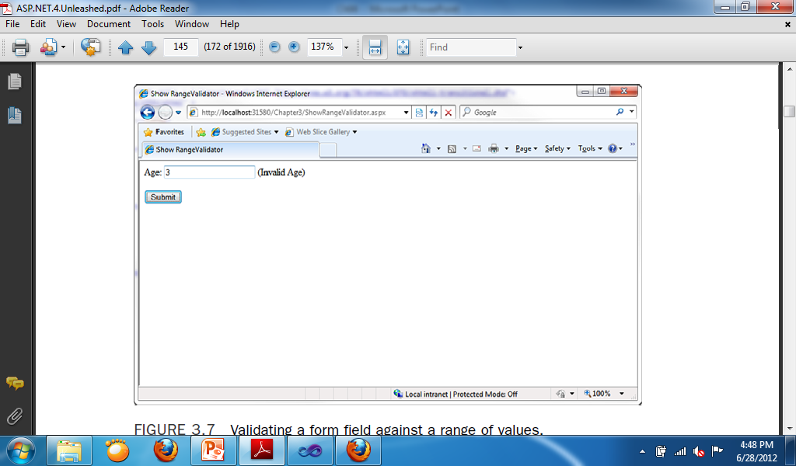

* This program checks the age if it is between 5 to 100.
* Add: TextBox, Label, RangeValidator, Button.
* Change:
  + RangeValidator
    - ControlToValidate:Textbox1
    - ErrorMesssage: (Invalid Age)
    - MinimumValue: 5
    - MaximumValue: 100
    - Type: Integer

**CompareValidator Control**

* The CompareValidator control enables you to perform three different types of validation tasks. You can use the CompareValidator to perform a data type check. In other words, you can use the control to determine whether a user has entered the proper type of value into a form field, such as a date in a birth date field.
* You also can use the CompareValidator to compare the value entered into a form field against a fixed value. For example, if you build an auction website, you can use the CompareValidator to check whether a new minimum bid is greater than the previous
* minimum bid.
* Finally, you can use the CompareValidator to compare the value of one form field against another. For example, you use the CompareValidator to check whether the value entered into the meeting start date is less than the value entered into the meeting end date.
* The CompareValidator has six important properties:
  + **ControlToValidate**—The ID of the form field validated.
  + **ErrorMessage**—The error message displayed when validation fails.
  + **Type**—The type of value compared. Possible values are String, Integer, Double, Date, and Currency.
  + **Operator**—The type of comparison to perform. Possible values are DataTypeCheck, Equal, GreaterThan, GreaterThanEqual, LessThan, LessThanEqual, and NotEqual.
  + **ValueToCompare**—The fixed value against which to compare.
  + **ControlToCompare**—The ID of a control against which to compare.
* **An important limitation of the CompareValidator concerns how it performs a data type check.** You cannot enter a long date(for example, December 25, 1966). You must enter a short date (for example, 12/25/1966). When validating currency amounts, you cannot enter the currency symbol. If these limitations concern you, you can use either the RegularExpression or CustomValidator controls to perform a more flexible data type check.

**Sample for CompareValidator Date Check**

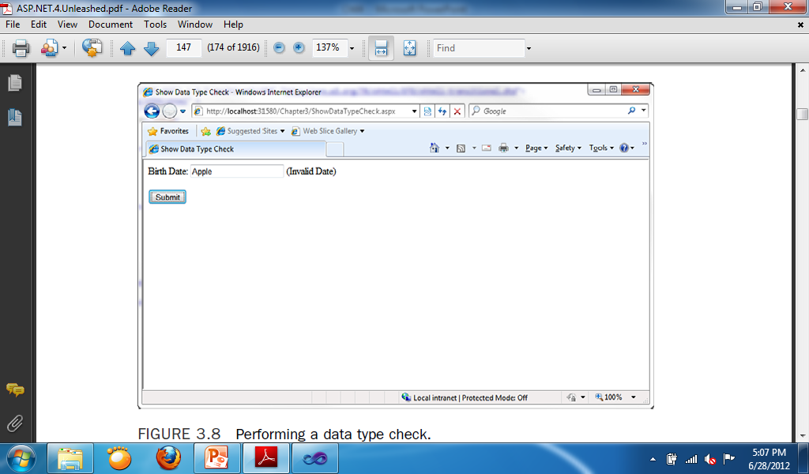

* Add: Label, TextBox, CompareValidator, Button
* Change:
  + CompareValidator
    - ErrorMessage: “Invalid Date”
    - ControlToValidate: textbox1
    - Type: Date
    - Operator: DateTypeCheck

**Sample for CompareValidator ValueToCompare**

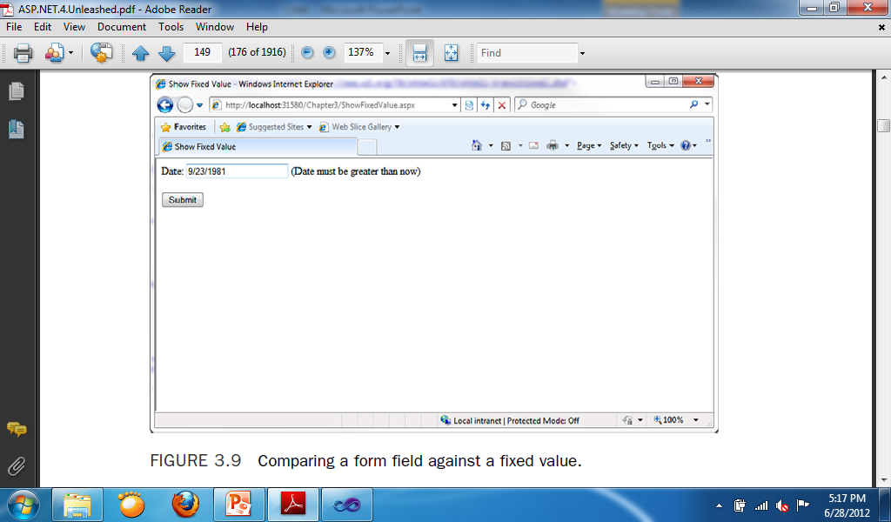

* Add: Label, TextBox, CompareValidator, Button
* Change:
  + CompareValidator:
    - ErrorMessage: “Date must be greater than now”
    - ControlToValidate: TextBox1
    - Type: Date
    - Operator: Greater Than
* Code for Form:
  + CompareValidator1.ValueToCompare = Today

**Sample for CompareValidator ControlsToCompare**

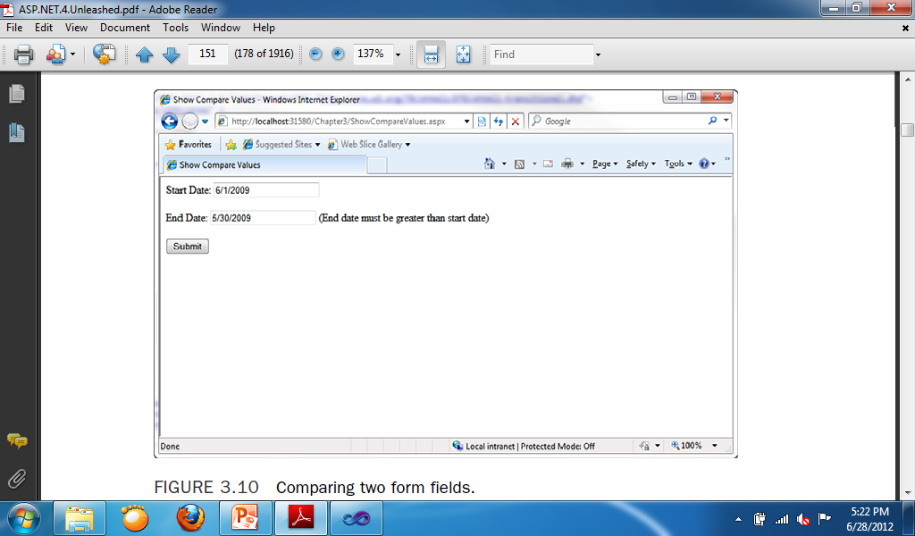

* Add: 2 Labels, 2 TextBox, CompareValidator, Button
* Change:
  + CompareValidator:
    - ErrorMessage: “End date must be greater than start date”.
    - ControlToValidate: TextBox2
    - ControlsToCompare: TextBox1
    - Type: Date
    - Operator: Greater than

**RegularExpressionValidator Control**

* The RegularExpressionValidator control enables you to compare the value of a form field against a regular expression. You can use a regular expression to represent string patterns such as email addresses, Social Security numbers, phone numbers, dates, currency amounts, and product codes.

**Sample for RegularExpressionValidator Email**

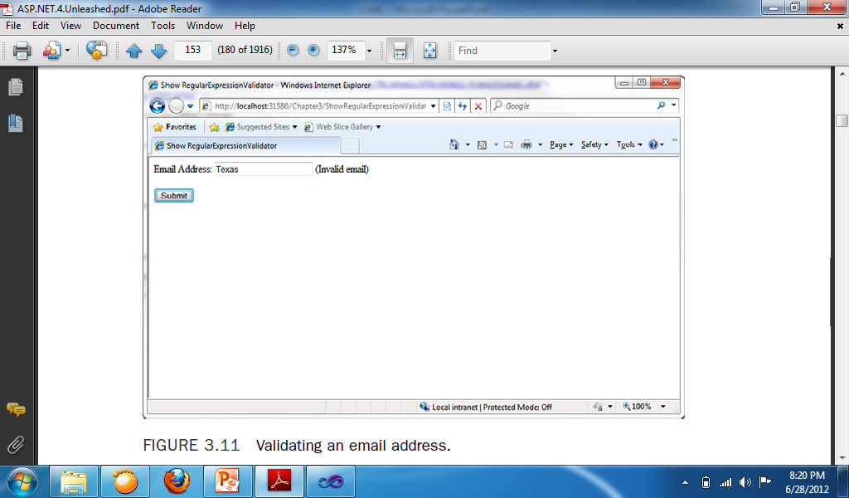

* Add: Label, TextBox, RegularExpressionValidator, Button
* Change:
  + RegularExpressionValidator:
    - ControlToValidate: TextBox1
    - ErrorMessage: “Invalid email”
    - ValidationExpression: Email

**ValidationSummary Control**

* The ValidationSummary control enables you to display a list of all the validation errors in a page in one location. This control is particularly useful when working with large forms. If a user enters the wrong value for a form field located toward the end of the page, the user might never see the error message. If you use the ValidationSummary control, however, you can always display a list of errors at the top of the form.
* Each of the validation controls includes an ErrorMessage property. We have not been using the ErrorMessage property to represent the validation error message. Instead, we have used the Text property. The distinction between the ErrorMessage and Text property is that any message that you assign to the ErrorMessage property appears in the ValidationSummary control, and any message that you assign to the Text property appears in the body of the page. Normally, you want to keep the error message for the Text property short (for example, ”Required!”). The message assigned to the ErrorMessage property, on the other hand, should identify the form field that has the error (for example, ”First name is required!”).

**Sample for ValidationSummary**

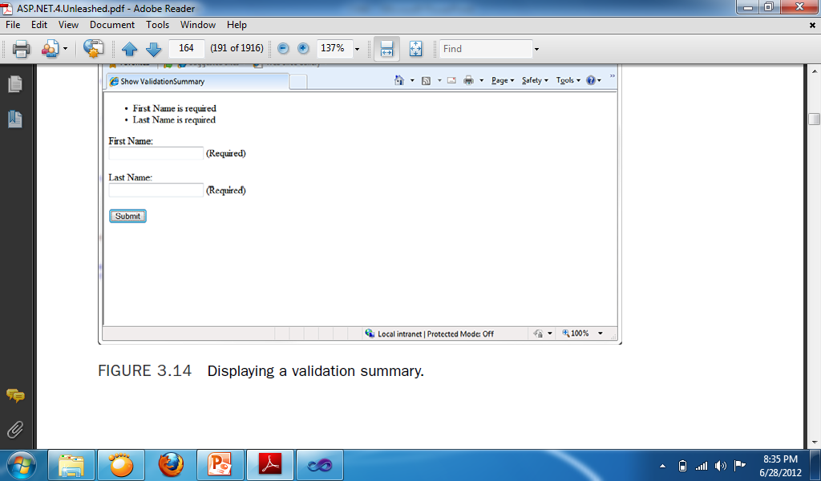

* Add: 2 Labels, 2 TextBoxes, 2 RequiredFieldValidator, ValidationSummary, Button
* Change:
  + RequiredFieldValidator1:
    - ControlToValidate: TextBox1
    - ErrorMessage: First Name is required
  + RequiredFieldValidator2:
    - ControlToValidate: TextBox2
    - ErrorMessage: Last Name is required

**Other Controls**

**List Controls**

**RadioButtonList**

* A RadioButtonList control that contains ListItem controls that correspond to the radio buttons. All the List controls use the ListItem control to represent individual list items.
* The ListItem control supports the following five properties:
  + **Attributes**—Enables you to add HTML attributes to a list item.
  + **Enabled**—Enables you to disable a list item.
  + **Selected**—Enables you to mark a list item as selected.
  + **Text**—Enables you to specify the text displayed by the List Item.
  + **Value—**Enables you to specify a hidden value associated with the List Item.

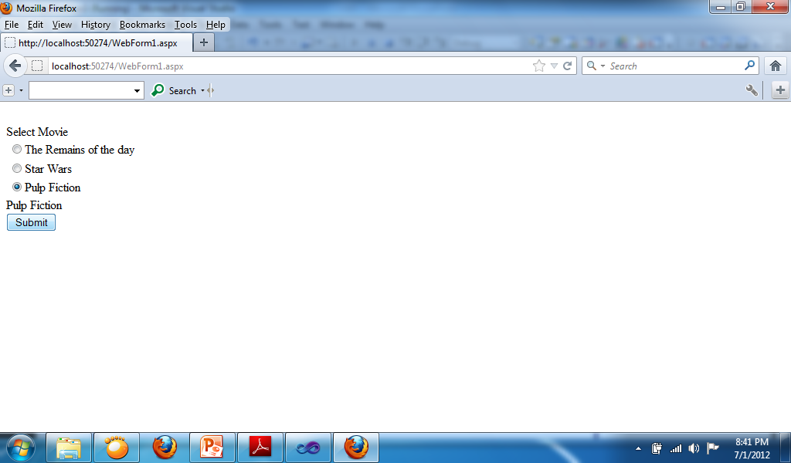

* Add: 2 Labels, RadioButtonListBox, Button
* Change:
  + RadioButtonListBox
    - Items:
      * “The Remains of the day”
      * “Star Wars”
      * “Pulp Fiction”
  + Code for Button:
    - Label2.Text = RadioButtonList1.SelectedItem.Text

**DropDownList**

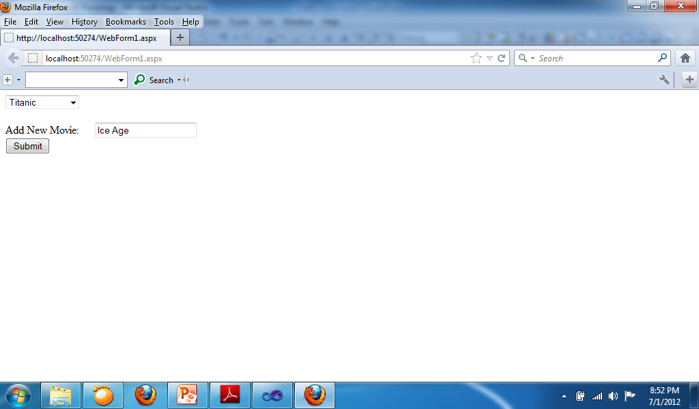

* Add: DropDownListBox, Label, TextBox, Button
* Code for Button:
  + DropDownList1.Items.Add(TextBox1.Text)

**Sample for Moving ListBox Items**

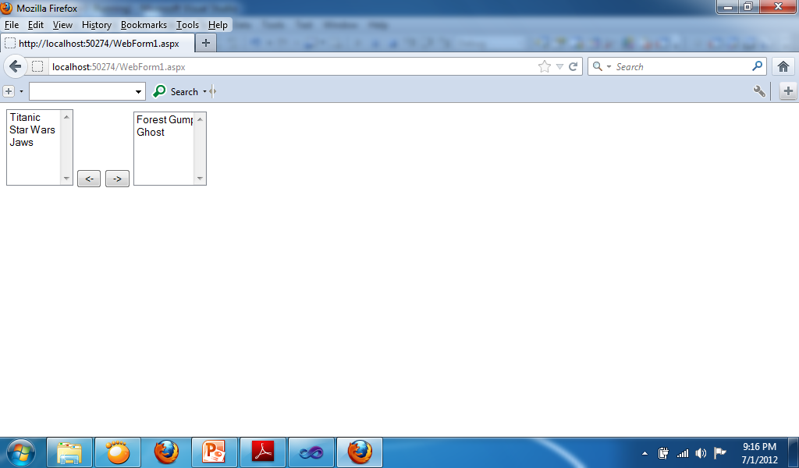

* Add: 2 ListBox, 2 Buttons
* Change:
  + ListBox1 Items:
    - Titanic
    - Star Wars
    - Jaws
    - Forest Gump
    - Ghost
* Code for “<-” Button:

If ListBox2.Items.Count <> 0 And ListBox2.SelectedIndex <> -1 Then

ListBox1.Items.Add(ListBox2.SelectedValue)

ListBox2.Items.Remove(ListBox2.SelectedValue)

End If

* Code for “->” Button:

If ListBox1.Items.Count <> 0 And ListBox1.SelectedIndex <> -1 Then

ListBox2.Items.Add(ListBox1.SelectedValue)

ListBox1.Items.Remove(ListBox1.SelectedValue)

End If

**Displaying a Calendar**

* The Calendar control enables you to display a calendar. You can use the calendar as a date picker or to display a list of upcoming events.
* The SelectionMode property enables you to change the behavior of the calendar so that you can not only select days, but also select weeks or months.

**Calendar Properties**

* **DayNameFormat**—Enables you to specify the appearance of the days of the week. Possible values are FirstLetter, FirstTwoLetters, Full, Short, and Shortest.
* **NextMonthText**—Enables you to specify the text that appears for the next month link.
* **NextPrevFormat**—Enables you to specify the format of the next month and previous month link. Possible values are CustomText, FullMonth, and ShortMonth.
* **PrevMonthText**—Enables you to specify the text that appears for the previous month link.
* **SelectedDate**—Enables you to get or set the selected date.
* **SelectedDates**—Enables you to get or set a collection of selected dates.
* **SelectionMode**—Enables you to specify how dates are selected. Possible values are Day, DayWeek, DayWeekMonth, and None.
* **SelectMonthText**—Enables you to specify the text that appears for selecting a month.
* **SelectWeekText**—Enables you to specify the text that appears for selecting a week.
* **ShowDayHeader**—Enables you to hide or display the day names at the top of the Calendar control.
* **ShowNextPrevMonth**—Enables you to hide or display the links for the next and previous months.
* **ShowTitle**—Enables you to hide or display the title bar displayed at the top of the calendar.
* **TitleFormat**—Enables you to format the title bar. Possible values are Month and MonthYear.
* **TodaysDate**—Enables you to specify the current date. This property defaults to the current date on the server.
* **VisibleDate**—Enables you to specify the month displayed by the Calendar control.vThis property defaults to displaying the month that contains the date specified byvTodaysDate.

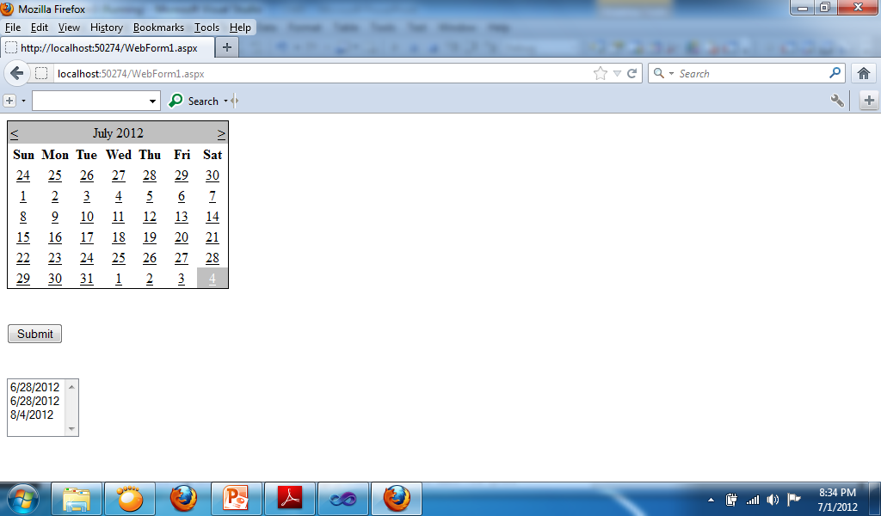

* Add: Calendar, ListBox, Button
* Code:
  + Button:
    - ListBox1.Items.Add(Calendar1.SelectedDate)

**Sample for DropDown List**

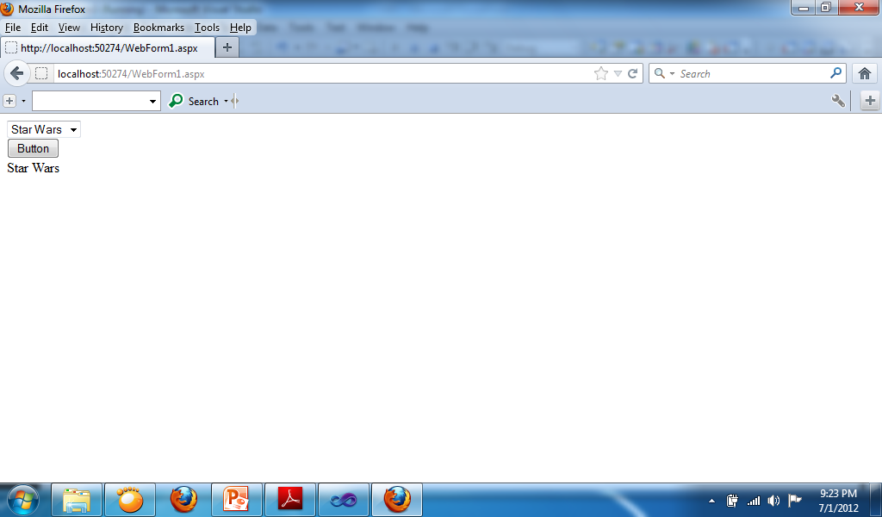

* Add: DropDownList, Button, Label
* Change:
  + DropDownList Items:
    - “Jaws”
    - “Ghost”
    - “Star Wars”
* Code for button:
  + Label1.Text = DropDownList1.Text

**Sample for RadioButtonList**

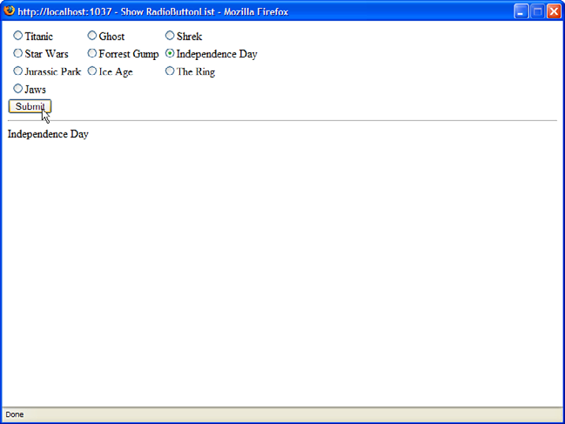

* Add: RadioButtonList, Button, Label
* Change
  + RadioButtonList Items
* Code for Button:
  + Label1.Text = RadioButtonList1.SelectedValue

**Sample for CheckBoxList**

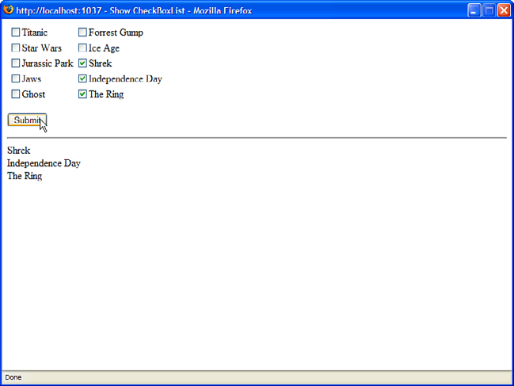

* Add: CheckBoxList, Button, Label
* Change:
  + CheckBoxList Items
* Code for Button:

Dim item As ListItem

Label1.Text = ""

For Each item In CheckBoxList1.Items

If (item.Selected) Then

Label1.Text += "<li>" + item.Text

End If

Next

**Session State**

**How to use Session State**

* ASP.NET uses *session state* to track the state of each user of an application. To do that, it creates a *session state object* that contains a *session ID.* This ID is passed to the browser and then back to the server with the next request so the server can identify the session associated with that request.
* Because session states sends only the session ID to the browser, it doesn’t slow response time. By default, though, session state objects are maintained in server memory so they can slow performance on the server side.

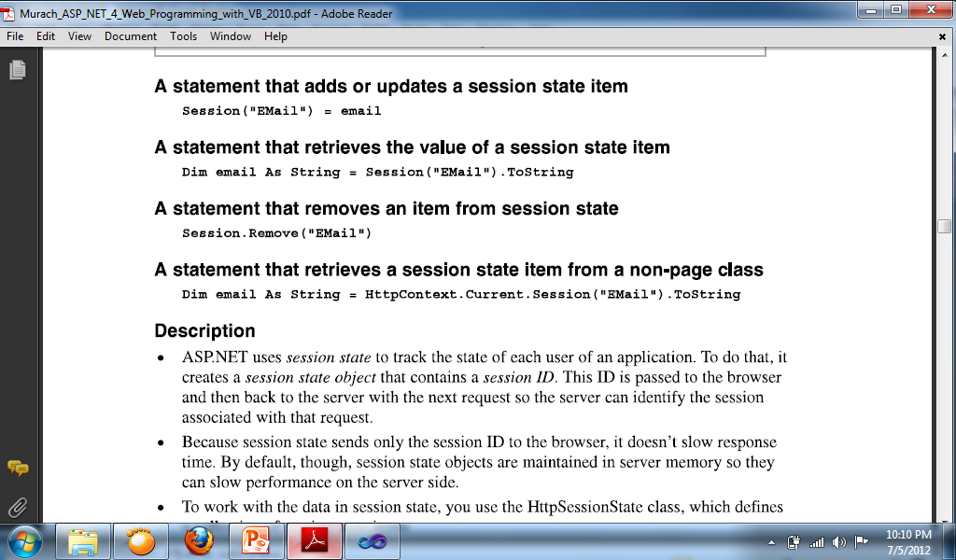

**Sample program using the Session state**

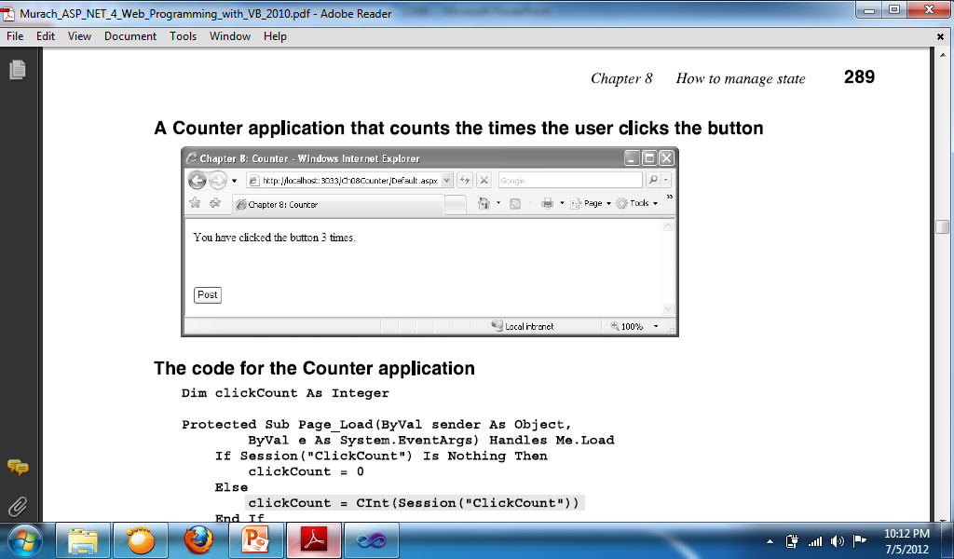

Dim clickcount As Integer

* Button Code:
  + clickcount += 1
  + Label1.Text = "You clicked the button " & clickcount & " times."
  + Session("SaveClickCount") = clickcount
* Page_Load Code:
  + If Session("SaveClickCount") Is Nothing Then
  + clickcount = 0
  + Else
  + clickcount = Session("SaveClickCount").ToString
  + End If

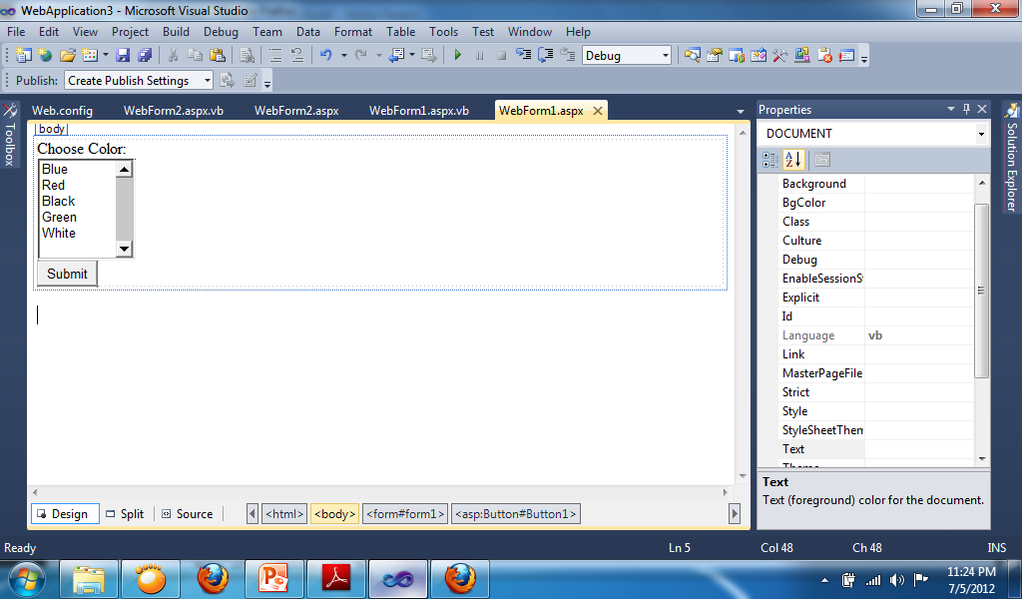 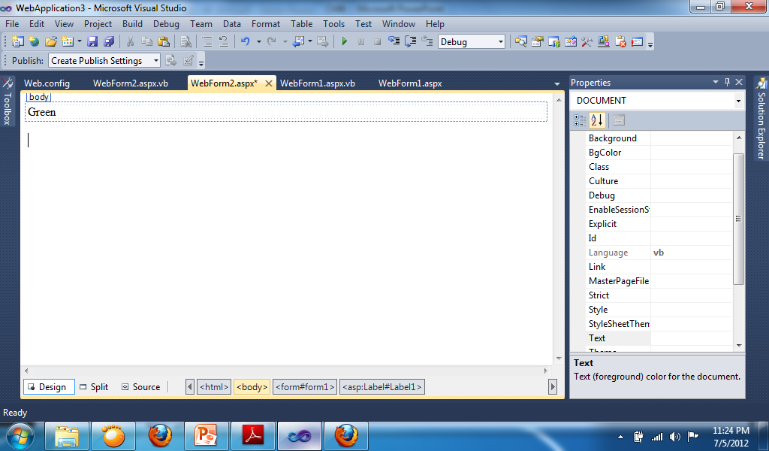

* WebForm1 Button Code:
  + Session("Color") = ListBox1.SelectedValue
  + Response.Redirect("Webform2.aspx")
* WebForm2 Page Load Code:
  + Label1.Text = Session("Color").ToString

**Changing color and text**

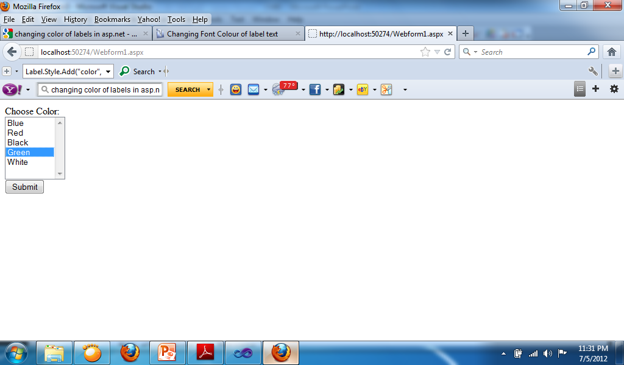 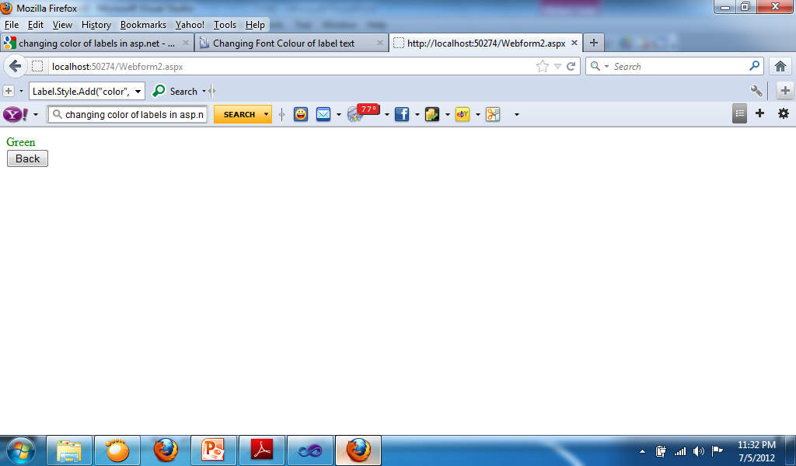

* Webform1 Button Code:
  + Session("Color") = ListBox1.SelectedValue
  + Response.Redirect("Webform2.aspx")
* Webform2 Page Load Code:
  + Label1.Style.Add("color", Session("color").ToString)
  + Label1.Text = Session("color").ToString
* Webform2 Button Code:
  + Response.Redirect("Webform1.aspx")

**Selecting dates**

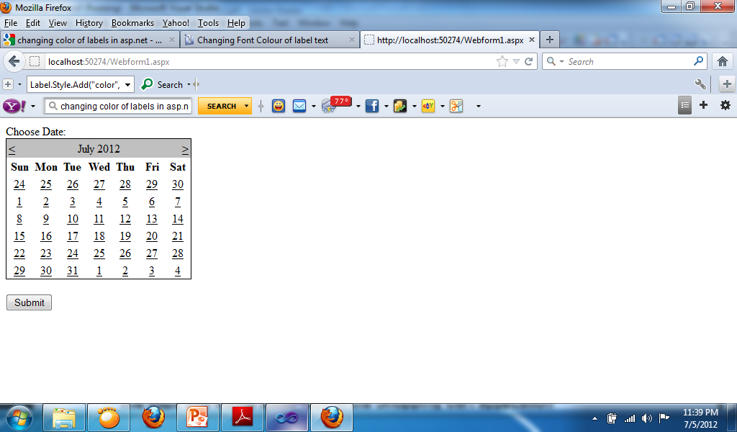 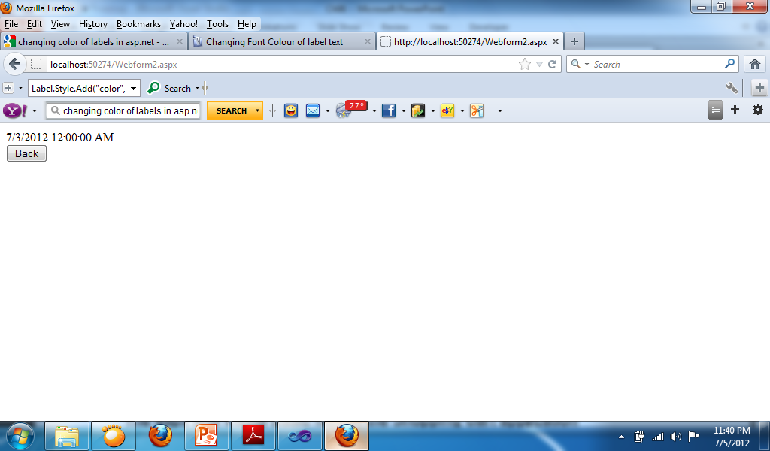

* Webform1 Button Code:
  + Session("DateSelect") = Calendar1.SelectedDate.Date
  + Response.Redirect("Webform2.aspx")
* Webform2 Page Load Code:
  + Label1.Text = Session("DateSelect").ToString
* Webform2 Button Code:
  + Response.Redirect("Webform1.aspx")

**Sample for transferring username to other webform**

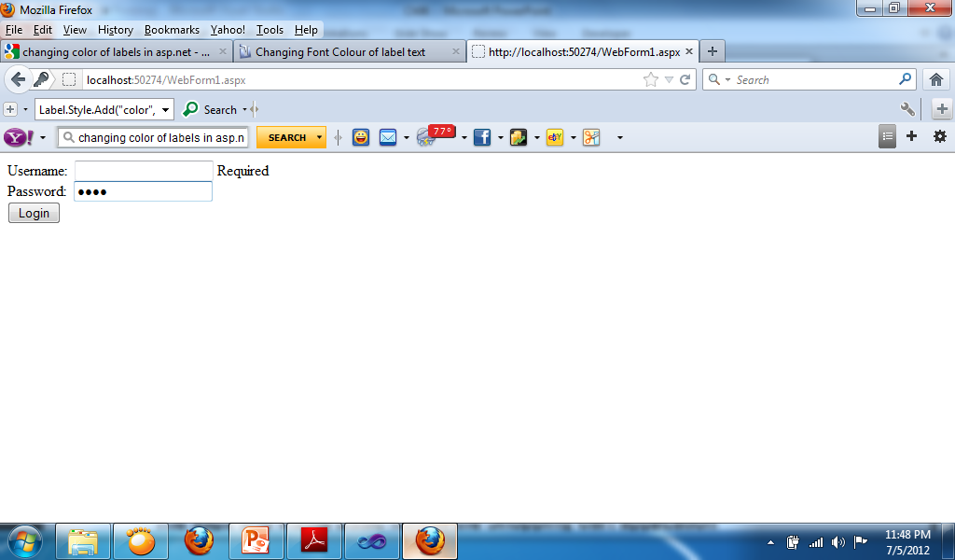 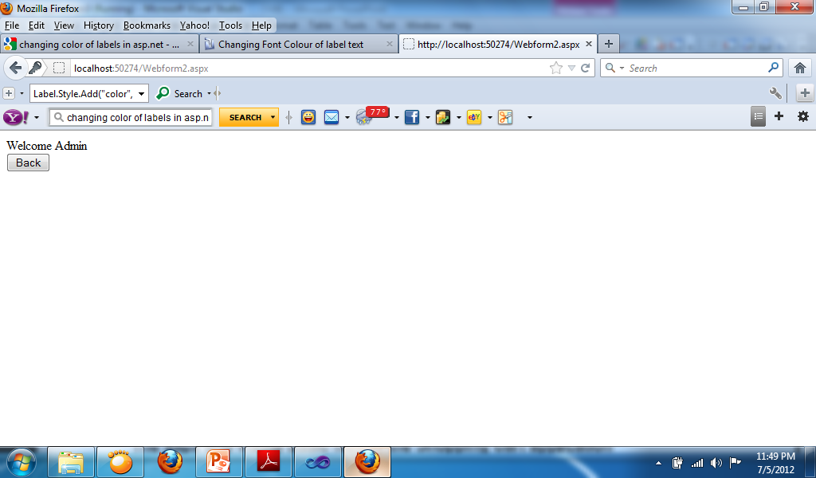

* Webform1 Button Code:
  + If IsValid Then
  + Session("username") = TextBox1.Text
  + Response.Redirect("Webform2.aspx")
  + End If
* Webform2 Page Load Code:
  + Label1.Text = "Welcome " + Session("username").ToString
* Webform2 Button Code:
  + Response.Redirect("Webform1.aspx")

**Designing Websites with Master Pages**

**Master Page**

* A Master Page enables you to share the same content among multiple content pages in a website. You can use a Master Page to create a common page layout.
* You also can use Master Pages to display common content in multiple pages. For example, if you want to display a standard header and footer in each page in your website, you can create the standard header and footer in a Master Page.

**Creating Master Pages**

* You create a Master Page in Visual Web Developer by selecting the Website menu option, Add New Item, and the Master Page item.
* You can see two special things about the Master Page. First, the file contains a <%@ Master %> directive instead of the normal <%@ Page %> directive. Second, the Master Page includes two ContentPlaceHolder controls.
* When the Master Page merges with a particular content page, the content from the content page appears in the areas marked by ContentPlaceHolder controls. You can add as many ContentPlaceHolders to a Master Page as you need.

**Create Content Pages**

* In Visual Web Developer, you create an ASP.NET page associated with a particular Master Page by selecting Website, Add New Item, and Web Form. Next, check the check box labeled Select Master Page. When you click Add, a dialog box appears that enables you to select a Master Page.

**Content Page**

* The content page does not contain any of the standard opening and closing XHTML tags.
* All these tags are contained in the Master Page. All the content contained in the content page must be added with Content controls.
* You must place all the content contained in a content page within the Content controls. If you attempt to place any content outside these controls, you get an exception.
* The Content control includes a ContentPlaceHolderID property. This property points to the ID of a ContentPlaceHolder control contained in the Master Page.
* Within a Content control, you can place anything that you would normally add to an ASP.NET page, including XHTML tags and ASP.NET controls.

**Modifying Master Page Content**

* Master Pages enable you to display the same content in multiple content pages. You quickly discover that you need to override the content displayed by a Master Page in the case of particular content pages.
* For example, normally the Master Page contains the opening and closing HTML tags, including the <title> tag. This means that every content page displays the same title. Normally, you want each page to display a unique title.

**Using the Title Attribute**

* If you need to modify only the title displayed in each content page, you can take advantage of the <%@ Page %> directive’s Title attribute. This attribute accepts any string value.
* <%@ Page Title="Content Title" Language="C#" MasterPageFile="~/MasterPage.master" AutoEventWireup="true" CodeFile="Default.aspx.cs" Inherits="_Default" %>
* There is one requirement for the Title attribute to work. The HTML <head> tag in the Master Page must be a server-side Head tag. In other words, the <head> tag must include the runat=”server” attribute. When you create a new Web Form or Master Page in Visual Web Developer, a server-side <head> tag is automatically created.

**Sample Master Page**

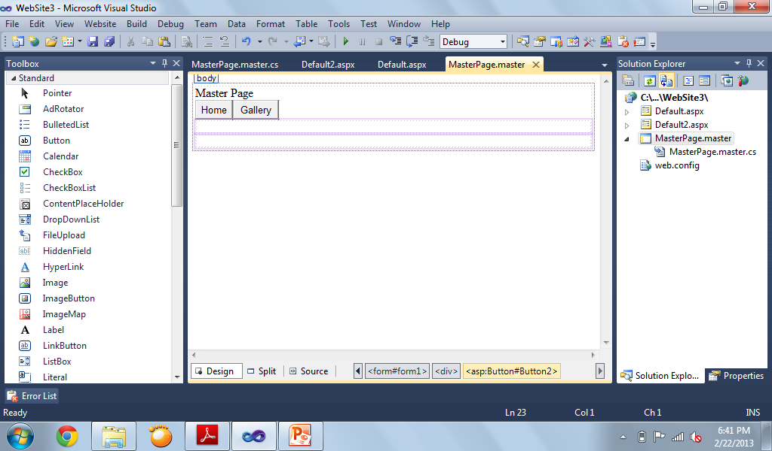

**Default.aspx (Home)**

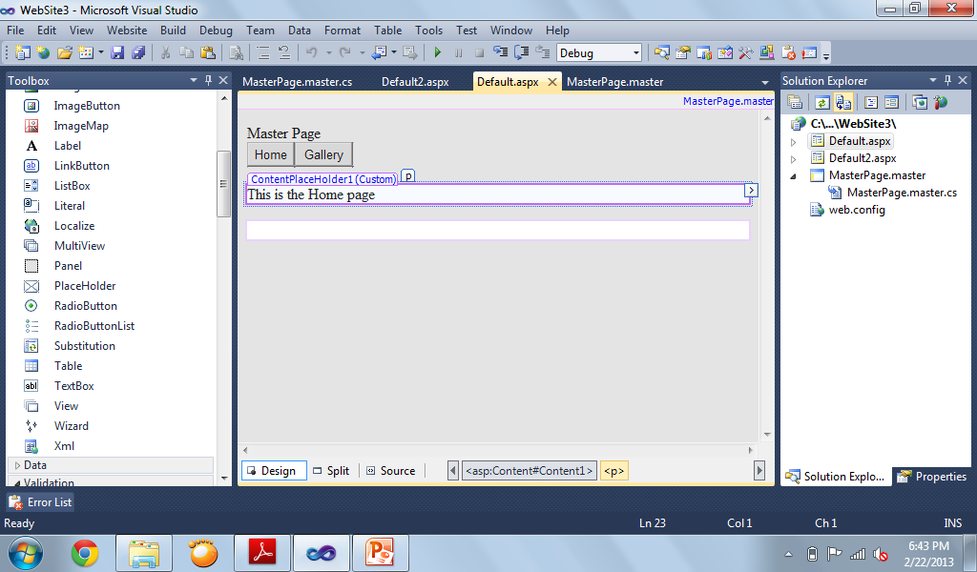

**Default2.aspx (Gallery)**

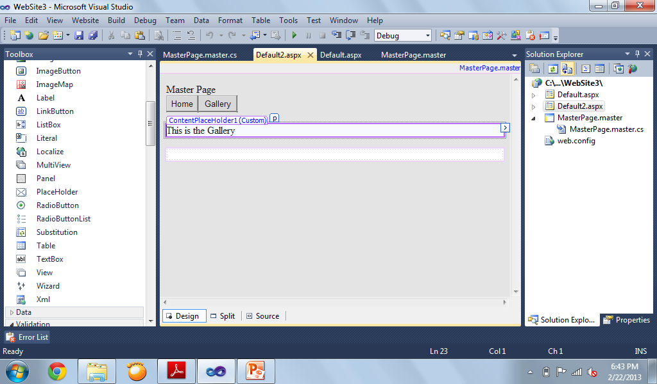

**Codes for the buttons on Master Page**

* Codes for Home Button:
  + ContentPlaceHolder1.Page.Response.Redirect("Default.aspx")

* Codes for Gallery Button:
  + ContentPlaceHolder1.Page.Response.Redirect("Default2.aspx")

**Designing Websites with Themes**

**Themes**

* An ASP.NET Theme enables you to apply a consistent style . Summary to the pages in your website. You can use a Theme to control the appearance of both the HTML elements and ASP.NET controls that appear in a page.
* Themes are different than Master Pages. A Master Page enables you to share content across multiple pages in a website. A Theme, on the other hand, enables you to control the appearance of the content.

**Creating Themes**

* When using Visual Web Developer, you can create a new Theme folder by right-clicking the name of your project in the Solution Explorer window and selecting Add Folder, Theme Folder.
* A Theme folder can contain a variety of different types of files, including images and text files. You also can organize the contents of a Theme folder by adding multiple subfolders to a Theme folder.
* Following are the most important types of files in a Theme folder:
  + . Skin Files
  + . Cascading Style Sheet Files
* Be careful about how you name your Theme (the folder name). The contents of a Theme folder are automatically compiled in the background into a new class. Don’t name a Theme with a class name that conflicts with an existing class name in your project.

**Adding Skins to Themes**

* A Theme can contain one or more Skin files. A Skin enables you to modify any of the properties of an ASP.NET control that have an effect on its appearance.
* For example, imagine that you decide that you want every TextBox control in your web application to appear with a yellow background color and a dotted border.
* You can name a Skin file anything you want. I recommend following a naming convention in which you name the Skin file after the name of the control that the Skin modifies.
* A Theme folder can contain a single Skin file that contains Skins for hundreds of controls.
* Alternatively, a Theme can contain hundreds of Skin files, each of which contains a single Skin. It doesn’t matter how you organize your Skins into files because everything in a Theme folder eventually gets compiled into one Theme class.
* The Skin file in next example contains a declaration of a TextBox control. The TextBox control includes a BackColor property set to the value Yellow and a BorderStyle property set to the value Dotted.
* The TextBox control includes a Runat=”Server” attribute, but it does not include an ID attribute. You must always include a Runat attribute, but you can never include the ID attribute when declaring a control in a Skin.

**Example using Theme1**

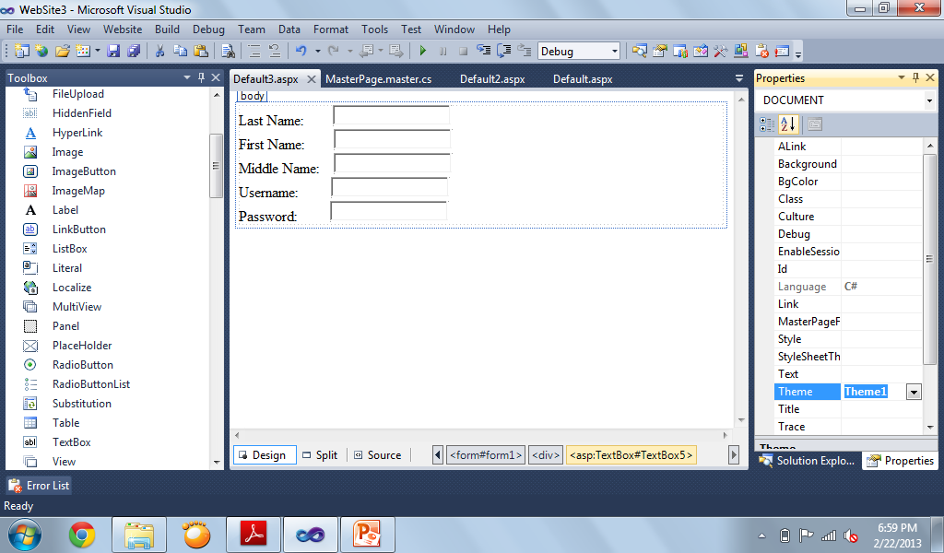

**Theme1: YellowTxtBox.skin**

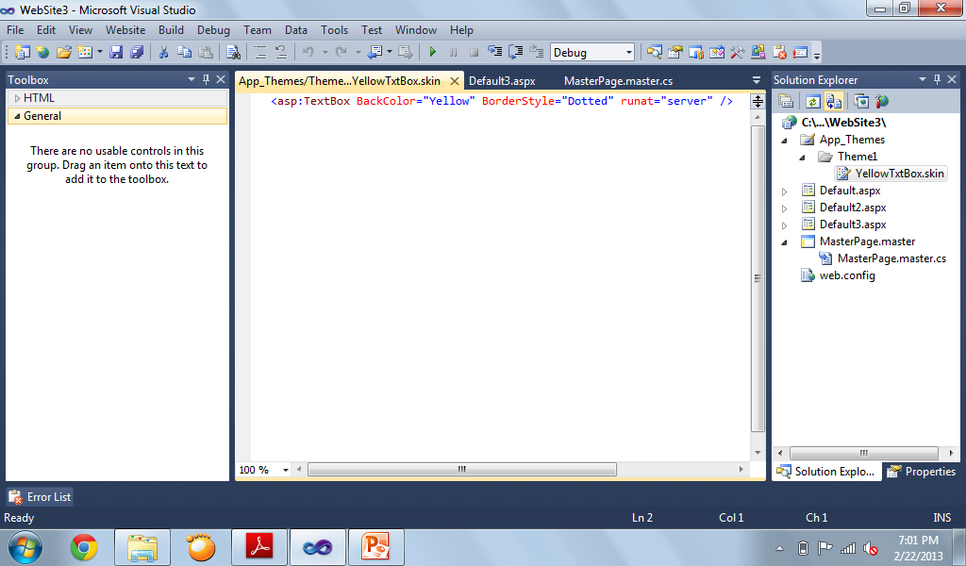

**Creating Named Skins**

* In the previous section, we created something called a Default Skin.
* A Default Skin is applied to every instance of a control of a certain type.
* For example, a Default Skin is applied to every instance of a TextBox control.
* You also have the option of creating a Named Skin. When you create a Named Skin, you can decide when you want to apply the Skin.
* For example, you might want required fields in a form to appear with a red border. In that case, you can create a Named Skin and apply the Skin to only particular TextBox controls.

**Example Skin2:**

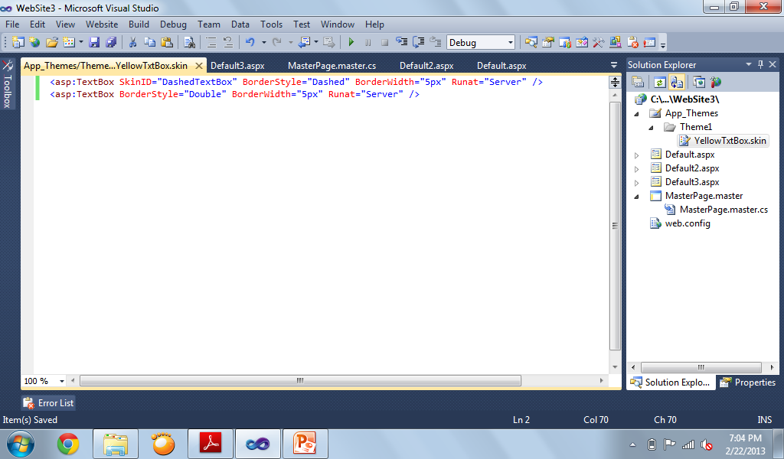

* The first TextBox is an example of a Named Skin and includes a SkinID property.
* The SkinID property represents the name of the Named Skin. You use the value of this property when applying the Skin in a page.
* It also includes a Default Skin for a TextBox control. The Default Skin does not include a SkinID property. If a TextBox control in a page is not associated with a Named Skin, the Default Skin is applied to the TextBox.
* A Theme can contain only one Default Skin for each type of control. However, a Theme can contain as many Named Skins as you want. Each Named Skin must have a unique name.
* The page in the next example contains two TextBox controls. The first TextBox control includes a SkinID attribute. This attribute causes the Named Skin to be applied to the control. The second TextBox, on the other hand, does not include a SkinID property. The Default Skin is applied to the second TextBox control.

**Example Skin2 Page**

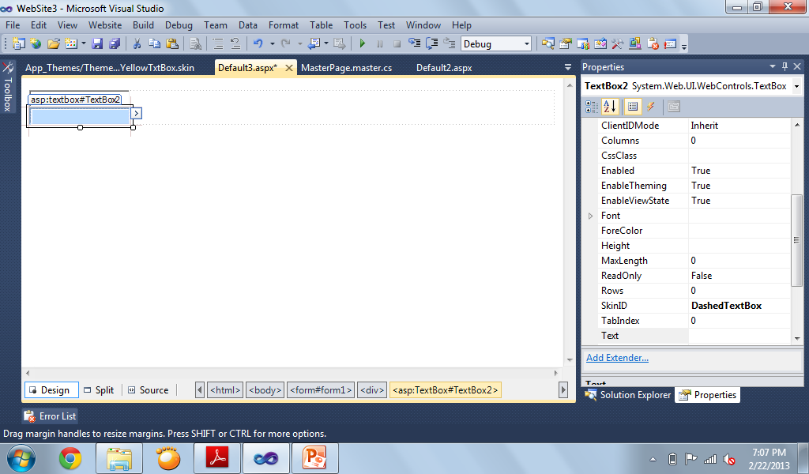

**Themes Versus StyleSheetThemes**

* When you apply a Theme to a page, the Skins in the Theme override any existing properties of the controls in the page. In other words, properties in a Skin override properties in a page.
* You can override any existing control properties that have an effect on the appearance of the control.
* However, there are situations in which you might want to override Skin properties. For example, you might want to display every Label in your website with an orange background color except for one Label. In that case, it would be nice if there were a way to override the Skin property.
* You can override Skin properties by applying a Theme to a page with the StyleSheetTheme attribute instead of the Theme attribute.

**Disabling Themes**

* Every ASP.NET control includes an EnableTheming property. You can use the EnableTheming property to prevent a Skin from being applied to a particular control in a page.
* You can disable a theme on a control by changing the **EnableTheming** property to **False**.

**ASP.NET AJAX**

* ASP.NET is a *server-side* technology for building web applications. Almost all the work happens on the web server and not the web browser. Whenever you perform an action in an ASP.NET page—such as clicking a button or sorting a GridView—the entire page must be posted back to the web server. Any significant action on a page results in a postback.
* When you perform a postback in an ASP.NET page, the entire page must be transported across the Internet from browser to server. Next, the .NET class that corresponds to the page must re-render the entire page again from scratch. Finally, the finished page must be sent back across the Internet to the browser. This whole long, slow, agonizing process must occur even if you are updating a tiny section of the page.

**AJAX (Asynchronous JavaScript and XML)**

* This enabled already-rendered web pages to make asynchronous calls and retrieve XML, which could then be used to modify the existing page.
* These are the commonly used controls in ASP.Net AJAX:
  + UpdatePanel Control
  + Timer Control

**Using the UpdatePanel Control**

* Microsoft’s server-side AJAX framework consists of one main control: UpdatePanel. The UpdatePanel control enables you to update a portion of a page without updating the entire page. In other words, it enables you to perform partial-page rendering.

**Sample using UpdatePanel control**

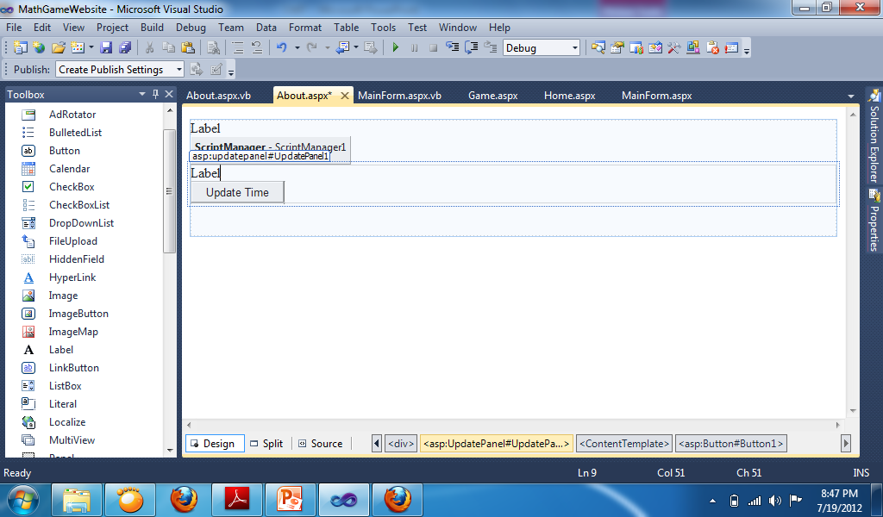 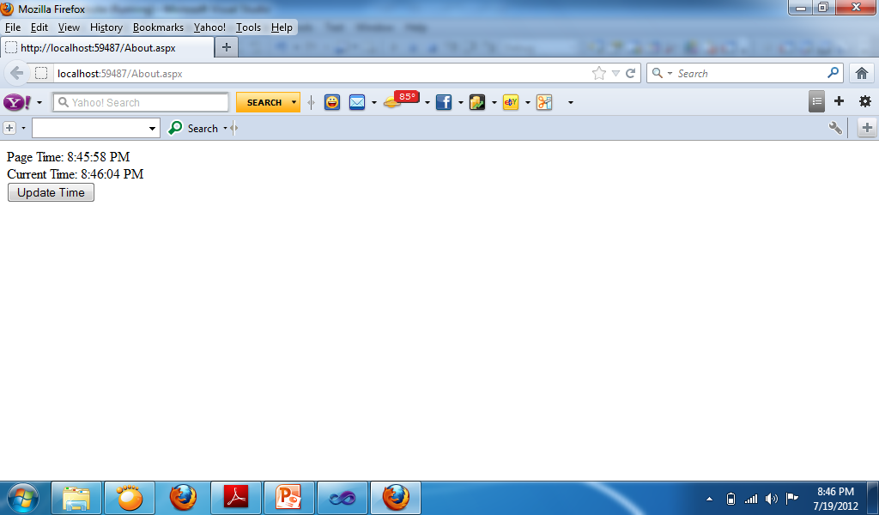

**Sample using Panel Control**

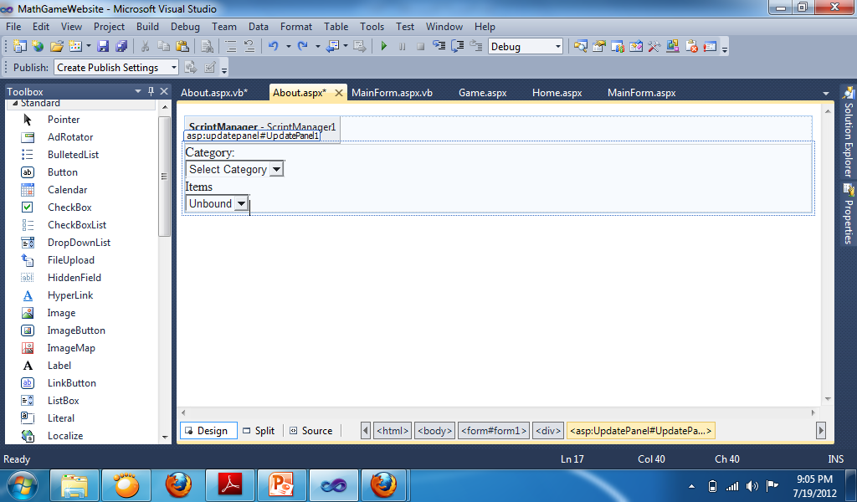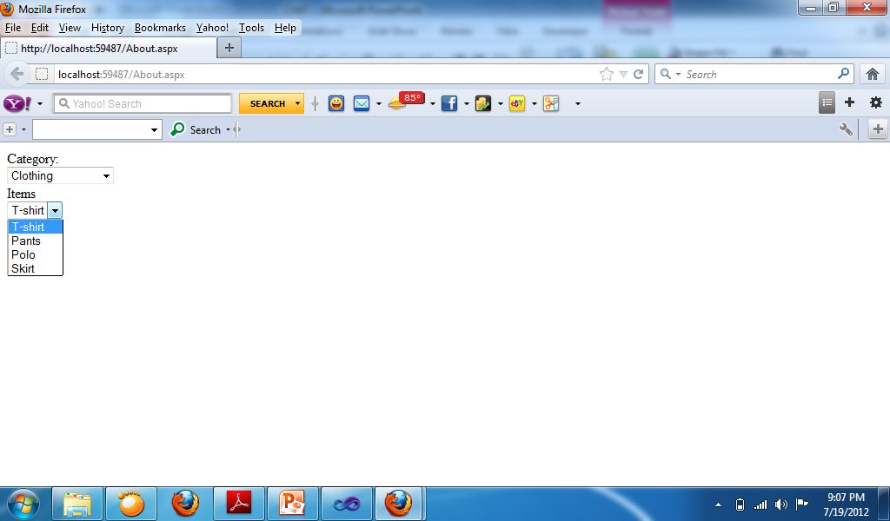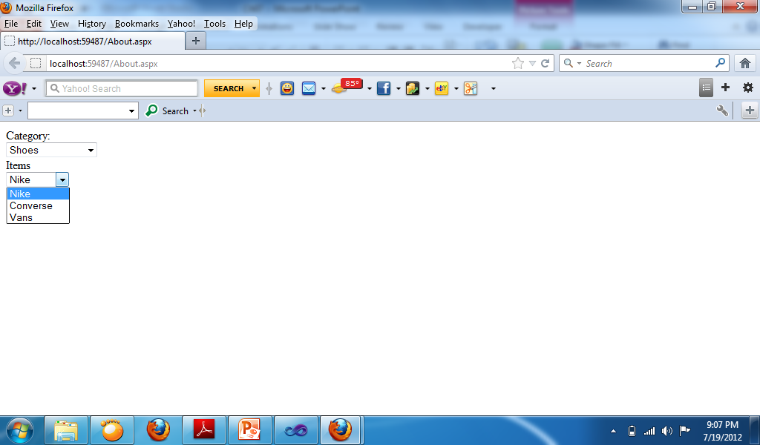

* Change Property of Dropdownlist:
  + AutoPostBack: True
* DropdownList 1 Code:

If DropDownList1.SelectedValue = "Clothing" Then

DropDownList2.Items.Clear()

DropDownList2.Items.Add("T-shirt")

DropDownList2.Items.Add("Pants")

DropDownList2.Items.Add("Polo")

DropDownList2.Items.Add("Skirt")

ElseIf DropDownList1.SelectedValue = "Shoes" Then

DropDownList2.Items.Clear()

DropDownList2.Items.Add("Nike")

DropDownList2.Items.Add("Converse")

DropDownList2.Items.Add("Vans")

Else

DropDownList2.Items.Clear()

End If

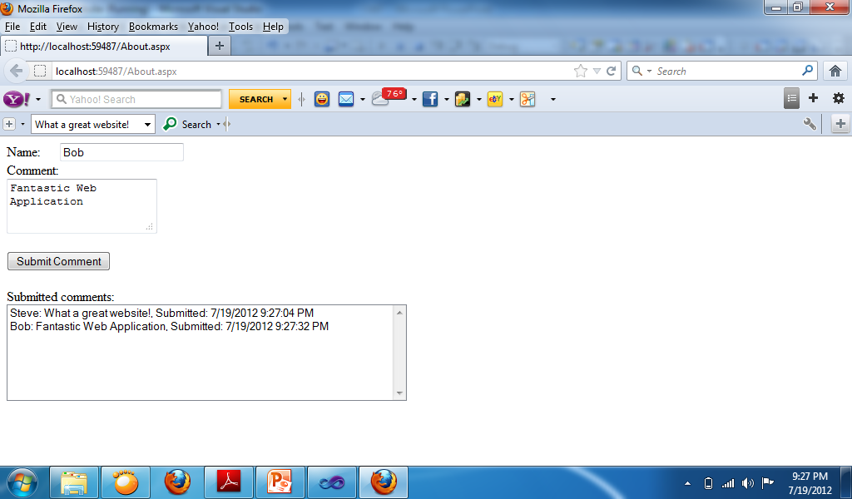

* Button Code:
  + ListBox1.Items.Add(TextBox1.Text + ": " + TextBox2.Text + ", Submitted: " + Now)

**AJAX Timer Control**

* The ASP.NET AJAX Timer control enables you to refresh an UpdatePanel (or the entire page) on a timed basis. The Timer control has one important property:
  + **Interval**—The amount of time, in milliseconds, between Tick events. The default value is 60,000 (1 minute).
* The Timer control raises a Tick event every so many milliseconds, depending on the value of its Interval property.
* If you don’t associate the Timer control with an UpdatePanel, the Timer posts the entire page back to the server performing a normal postback.

**Using Timer Control**

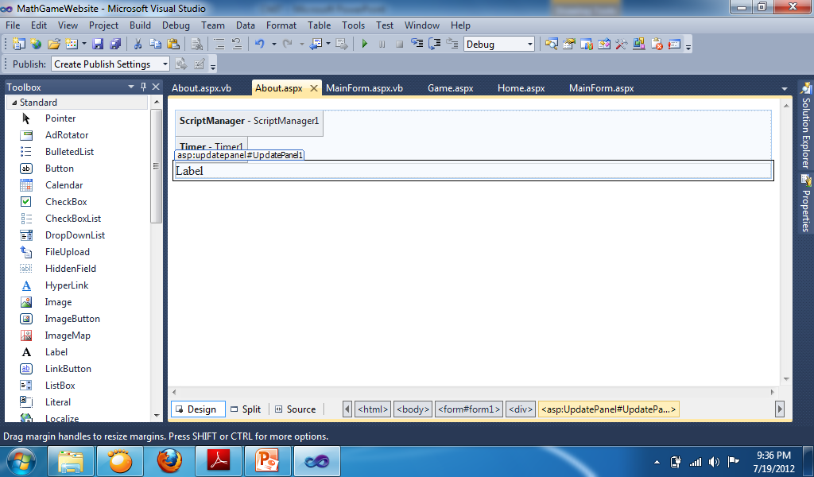 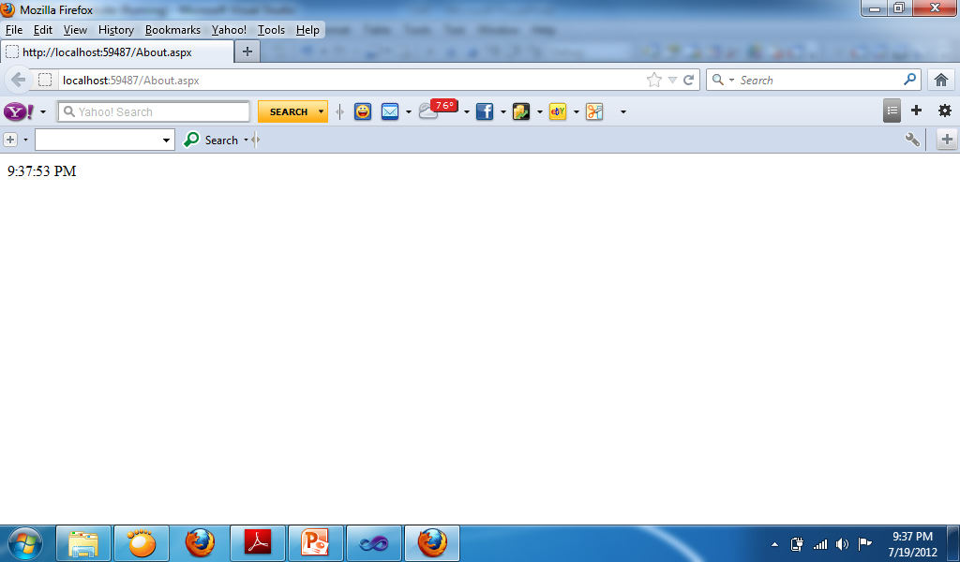

* Change Property:
  + Timer:
    - Interval: 1000
  + UpdatePanel:
    - Triggers: AsyncPostBack, ControlID: Timer1, EventName: Tick
* Timer Code:
  + Label1.Text = TimeOfDay

**Conditional update in UpdatePanel**

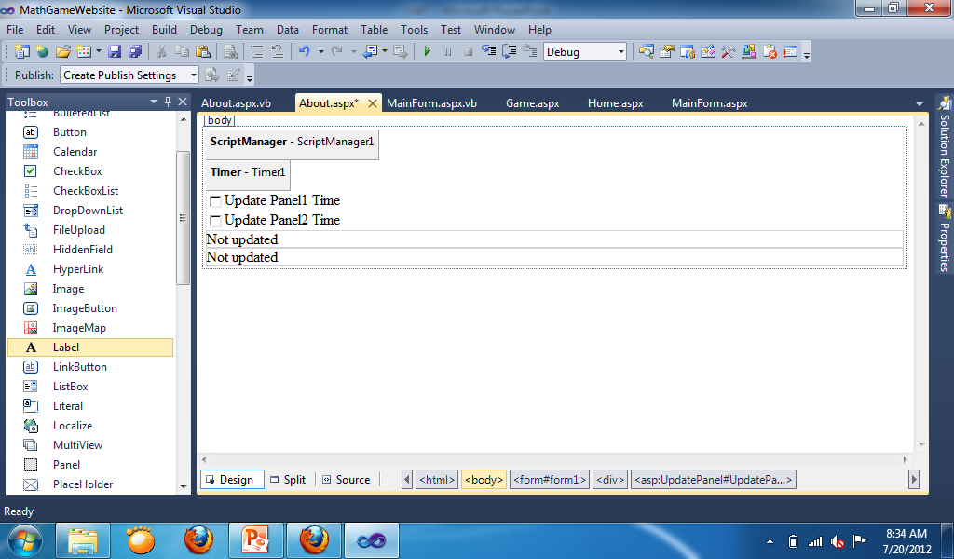 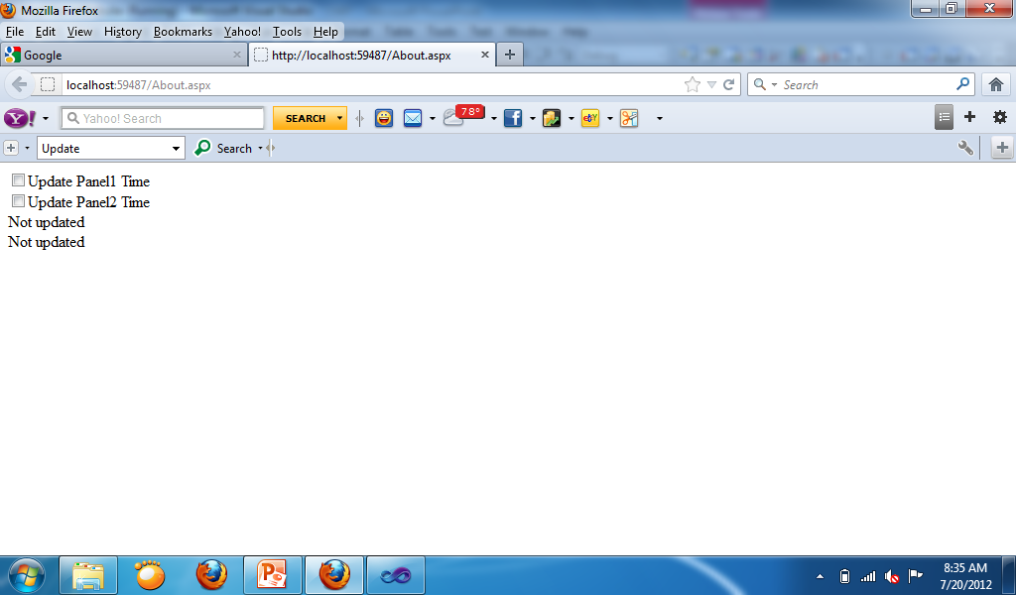 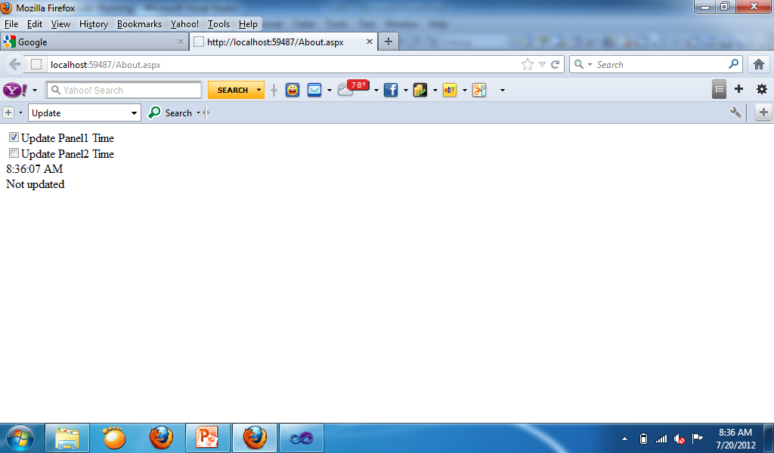 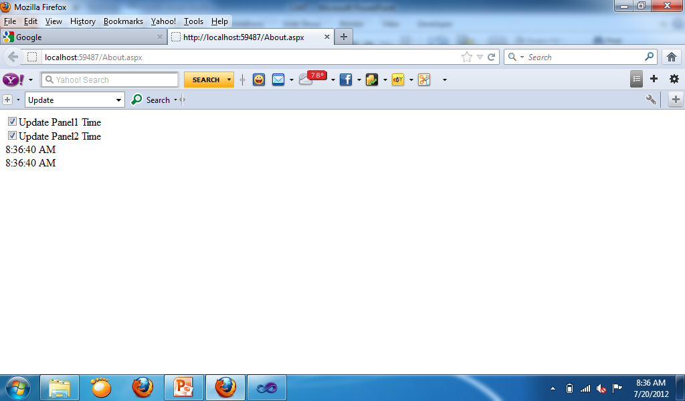

* Change Property:
  + Update Panel 1:
    - Triggers: AsyncPostBack, ControlID: Timer1, EventName: Tick
  + Update Panel 2:
    - Triggers: AsyncPostBack, ControlID: Timer1, EventName: Tick
* Code Timer1:

If CheckBox1.Checked = True Then

Label1.Text = TimeOfDay

End If

If CheckBox2.Checked = True Then

Label2.Text = TimeOfDay

End If

**AJAX Control Toolkit**

**How to install AJAX Control Toolkit**

* To install the ASP.NET Ajax Control Toolkit manually into either Visual Studio 2010 or Visual Studio 2008 you will fist need to download the latest version of the toolkit.
* Extract the files somewhere on your hard drive remembering the path to where you extracted the files.
* Next you will need to add the toolkit to your toolbar within Visual Studio. To do so right click on an empty portion of your toolbar and click on “Add Tab”. This will add a new tab to your toobar. Next name the toolbar something like “ASP.NET AJAX Control Toolkit”.
* Next right click on your newly created tab and click on “Choose Items..”. Make sure the “.NET Framework Components” tab is selected then click on “Browse…”. Browse to where you extracted the toolkit files to earlier and open the file named “AjaxControlToolkit.dll” then click “OK”. You should now have available to you the ASP.NET AJAX Control Toolkit controls within your Toolbox.

**Accordion**

* The Accordion is a web control that allows you to provide multiple panes and display them one at a time. It is like having several [CollapsiblePanels](http://www.ajaxcontroltoolkit.com/CollapsiblePanel/CollapsiblePanel.aspx) where only one can be expanded at a time. The Accordion is implemented as a web control that contains AccordionPane web controls. Each AccordionPane control has a template for its Header and its Content. We keep track of the selected pane so it stays visible across postbacks.
* It also supports three AutoSize modes so it can fit in a variety of layouts.
  + **None** - The Accordion grows/shrinks without restriction. This can cause other elements on your page to move up and down with it.
  + **Limit** - The Accordion never grows larger than the value specified by its Height property. This will cause the content to scroll if it is too large to be displayed.
  + **Fill** - The Accordion always stays the exact same size as its Height property. This will cause the content to be expanded or shrunk if it isn't the right size.

**Properties**

* **SelectedIndex** - The AccordionPane to be initially visible
* **HeaderCssClass** - Name of the CSS class to use for the headers. This can be either applied to the Accordion as a default for all AccordionPanes, or an individual AccordionPane.
* **HeaderSelectedCssClass** - Name of the CSS class to use for the selected header. This can be either applied to the Accordion as a default for all AccordionPanes, or an individual AccordionPane.
* **ContentCssClass** - Name of the CSS class to use for the content. This can be either applied to the Accordion as a default for all AccordionPanes, or an individual AccordionPane.
* **FadeTransitions** - True to use the fading transition effect, false for standard transitions.
* **TransitionDuration** - Number of milliseconds to animate the transitions
* **FramesPerSecond** - Number of frames per second used in the transition animations
* **AutoSize** - Restrict the growth of the Accordion. The values of the AutoSize enumeration are described above.
* **RequireOpenedPane** - Prevent closing the currently opened pane when its header is clicked (which ensures one pane is always open). The default value is true.
* **Panes** - Collection of AccordionPane controls

**AlwaysVisible**

* The AlwaysVisibleControl is a simple extender allowing you to pin controls to the page so that they appear to float over the background body content when it is scrolled or resized. It targets any ASP.NET control and always keeps the position a specified distance from the desired horizontal and vertical sides.
* To avoid having the control flash and move when the page loads, it is recommended that you absolutely position the control in the desired location in addition to attaching the extender.

**AlwaysVisible Properties**

* **TargetControlID** - ID of control for this extender to always make visible
* **HorizontalOffset** - Distance to the HorizontalSide edge of the browser in pixels from the same side of the target control. The default is 0 pixels.
* **HorizontalSide** - Horizontal edge of the browser (either Left, Center, or Right) used to anchor the target control. The default is Left.
* **VerticalOffset** - Distance to the VerticalSide edge of the browser in pixels from the same side of the target control. The default is 0 pixels.
* **VerticalSide** - Vertical edge of the browser (either Top, Middle, or Bottom) used to anchor the target control. The default is Top.
* **ScrollEffectDuration** - Length in seconds of the scrolling effect to last when the target control is repositioned. The default is .1 second.

**BalloonPopupExtender**

* The BalloonPopupExtender control displays a popup which can contain any content. For example, you can use the BalloonPopupExtender to display help information when you move focus to a TextBox control.
* The BalloonPopupExtender supports three different styles: Balloon, Rectangle, and Custom. You can select among three different sizes for the popup: Small, Medium, and Large. If you set the BalloonPopup style to the value Custom then you can define a custom appearance for the BalloonPopup. In that case, you also need to set the CustomCssUrl property to point to a custom style sheet.
* This control can be set to 5 positions - TopLeft, TopRight, BottomLeft, BottomRight and Auto. If you select the value Auto then the position of the BalloonPopup is determined automatically based on available space.
* You can set the BalloonPopExtender to be triggered by the MouseOver, Focus or Click events. The control is hidden automatically when you click outside the Balloon Popup.

**BalloonPopupExtender Properties**

* **BalloonPopupControlID** - The ID of the control to display.
* **Position** - Optional setting specifying where the popup should be positioned relative to the target control. (TopRight, TopLeft, BottomRight, BottomLeft, Auto) Default value is Auto.
* **OffsetX/OffsetY** - The number of pixels to offset the Popup from its default position, as specified by Position. Default value is 0.
* **BalloonStyle** - Optional setting specifying the theme of balloon popup. (Cloud, Rectangle, Custom). Default value is Rectangle.
* **BalloonSize** - Optional setting specifying the size of balloon popup. (Small, Medium and Large). Default value is Small.
* **CustomCssUrl** - This is required if user choose BalloonStyle to Custom. This specifies the url of custom css which will display custom theme.
* **UseShadow** - Optional setting specifying whether to display shadow of balloon popup or not.
* **ScrollBars** - Optional setting specifying whether to display scrollbar if contents are overflowing. This property contains 5 options - None, Horizontal, Vertical, Both and Auto. Default value is Auto.
* **DisplayOnMouseOver** - Optional setting specifying whether to display balloon popup on the client onMouseOver event. Default value is false.
* **DisplayOnFocus** - Optional setting specifying whether to display balloon popup on the client onFocus event. Default value is false.
* **DisplayOnClick** - Optional setting specifying whether to display balloon popup on the client onClick event. Default value is true.

**CalendarExtender**

* Calendar is an ASP.NET AJAX extender that can be attached to any ASP.NET TextBox control. It provides client-side date-picking functionality with customizable date format and UI in a popup control. You can interact with the calendar by clicking on a day to set the date, or the "Today" link to set the current date.
* In addition, the left and right arrows can be used to move forward or back a month. By clicking on the title of the calendar you can change the view from Days in the current month, to Months in the current year. Another click will switch to Years in the current Decade. This action allows you to easily jump to dates in the past or the future from within the calendar control.
* The page uses the culture setting **English (United States)** which was specified by the browser. The page properties have Culture="auto" and UICulture="auto" set to enable the same.

**CalendarExtender Properties**

* **TargetControlID** - The ID of the TextBox to extend with the calendar.
* **CssClass** - Name of the CSS class used to style the calendar. See the Calendar Theming section for more information.
* **Format** - [Format string](http://msdn2.microsoft.com/en-us/library/bb79761a-ca08-44ee-b142-b06b3e2fc22b.aspx) used to display the selected date.
* **PopupPosition** - Indicates where the calendar popup should appear at the BottomLeft(default), BottomRight, TopLeft, TopRight, Left or Right of the TextBox.
* **SelectedDate** - Indicates the date the Calendar extender is initialized with.
* **StartDate** - Indicates start date for range that available for selection.
* **EndDate** - Indicates end date for range that available for selection.

**CollapsiblePanel**

* The CollapsiblePanel is a very flexible extender that allows you to easily add collapsible sections to your web page. This extender targets any ASP.NET Panel control. The page developer specifies which control(s) on the page should be the open/close controller for the panel, or the panel can be set to automatically expand and/or collapse when the mouse cursor moves in or out of it, respectively.
* The page developer can specify whether the panel should scroll when it does not expand to the full size of its contents, and can also specify whether the panel expands in the height or width dimensions.

**CollapsiblePanel Properties**

* **CollapsedSize** - The size of the target, in pixels, when it is in the collapsed state.
* **ExpandedSize** - The size of the target, in pixels, when it is in the opened state.
* **Collapsed** - Specifies that the object should initially be collapsed or expanded. Set this to match your initial size. In this case, we initially set the panel to a height of 0 to match the CollapsedSize property, so when the page first renders, we don't see the panel expanded.
* **AutoCollapse** - True to automatically collapse when the mouse is moved off the panel.
* **ExpandControlID/CollapseControlID** - The controls that will expand or collapse the panel on a click, respectively. If these values are the same, the panel will automatically toggle its state on each click.

**ColorPicker**

* ColorPicker is an ASP.NET AJAX extender that can be attached to any ASP.NET TextBox control. It provides client-side color-picking functionality with UI in a popup control. You can interact with the color picker by clicking on a color to select the color. Optionally, a PopupButton control and a SampleControl can be provided which allows customizing ColorPicker's behavior.
* In addition, if a custom color value is entered in a targeted TextBox then the sample control if it's used can demonstrate a custom color even if it's not in a color picker palette.

**ColorPicker Properties**

* **PopupButtonID** - The ID of a control to show the ColorPicker popup when clicked. If this value is not set, the color picker will pop up when the textbox receives focus.
* **SampleControlID** - The ID of a control to show the ColorPicker's selected color. If this value is set and the color picker popup is open the background color of the sample control will sample the hovered color. If this value is not set, the selected color is not shown.
* **PopupPosition** - Indicates where the color picker popup should appear at the BottomLeft(default), BottomRight, TopLeft, TopRight, Left or Right of the TextBox.
* **SelectedColor** - Indicates the color value the ColorPicker extender is initialized with.

**ConfirmButton**

* ConfirmButton is a simple extender that catches clicks on a button (or any instance of a type derived from Button) and displays a message to the user. If the "OK" button is clicked, the button or link functions normally. If not, the click is trapped and the button will not perform its default submit behavior.

**ConfirmButton Properties**

* **ConfirmText** - The text to show when you want to confirm the click. **ConfirmOnFormSubmit** - True if the confirm dialog should wait until just before the form submits to display. This is useful when ASP.NET validators are in use and the confirm should be shown only after all validators pass.

**FilteredTextBox**

* FilteredTextBox is an extender which prevents a user from entering invalid characters into a text box. Note that since this effect can be avoided by deactivating JavaScript, you should use this extender as a convenience for your users, but you must never expect that the data being sent to the server consists of "valid" chars only.

**FilteredTextBox Properties**

* **FilterType** - A the type of filter to apply, as a comma-separated combination of**Numbers**, **LowercaseLetters**, **UppercaseLetters**, and **Custom**. If Custom is specified, the ValidChars field will be used in addition to other settings such as Numbers.
* **ValidChars** - A string consisting of all characters considered valid for the text field, if "Custom" is specified as the filter type. Otherwise this parameter is ignored.
* **InvalidChars** - A string consisting of all characters considered invalid for the text field, if "Custom" is specified as the filter type and "InvalidChars" as the filter mode. Otherwise this parameter is ignored.

**HoverMenu**

* HoverMenu is an ASP.NET AJAX extender that can be attached to any ASP.NET WebControl, and will associate that control with a popup panel do display additional content. When the user moves the mouse cursor over the main control two things happen:
  + The popup panel is displayed at a position specified by the page developer (at the left, right, top, or bottom of the main control)
  + Optionally, a CSS style can be applied to the control

**HoverMenu Properties**

* **PopupControlID** - The ID of the control to display when mouse is over the target control.
* **PopupPostion** - Where the popup should be positioned relative to the target control. Can be Left (Default), Right, Top, Bottom, Center.
* **OffsetX/OffsetY** - The number of pixels to offset the Popup from it's default position, as specified by PopupPosition. So if you want it to popup to the left of the target and have a 5px space between the popup and the target, the value should be "-5".
* **PopDelay** - The time, in milliseconds, for the popup to remain visible after the mouse moves away from the target control. Default is 100.

**ListSearchExtender**

* The ListSearchExtender lets you search for items in a ListBox or DropDownList by typing. The extender performs an incremental search within the ListBox based on what has been typed so far.

**ListSearchExtender Properties**

* **PromptText** - Message to display when the ListBox or DropDownList is given focus. Default is 'Type to search'. The PromptText is replaced by the search text typed by the user.
* **PromptPosition** - Indicates whether the message should appear at the Top or Bottom of the ListBox. The default is Top.
* **QueryPattern** - Indicates how the typed characters should be used in the search query. The default pattern queries for results that start with the typed word.
* **IsSorted** - Indicates if items added to the List are expected to be sorted. The default is false. If set to true it allows the code to perform a faster search instead of having to determine the same before performing the search.
* **QueryTimeout** - Indicates whether the search query should be reset after the timeout if no match is found. The default is 0, meaning no auto reset behavior.

**RoundedCorners**

* The RoundedCorners extender applies rounded corners to existing elements. To accomplish this it inserts elements before and after the element that is selected, so the overall height of the element will change slightly. You can choose the corners of the target panel that should be rounded by setting the Corners property on the extender to None, TopLeft, TopRight, BottomRight, BottomLeft, Top, Right, Bottom, Left, or All.

**RoundedCorners Properties**

* **Radius** - The radius of the corners (and height of the added area). Default is 5.
* **Corners** - The corners of the target panel that will be rounded (can be None, TopLeft, TopRight, BottomRight, BottomLeft, Top, Right, Bottom, Left, or All)

**TextBoxWatermark**

* TextBoxWatermark is an ASP.NET AJAX extender that can be attached to an ASP.NET TextBox control to get "watermark" behavior. When a watermarked TextBox is empty, it displays a message to the user with a custom CSS style. Once the user has typed some text into the TextBox, the watermarked appearance goes away. The typical purpose of a watermark is to provide more information to the user about the TextBox itself without cluttering up the rest of the page.

**TextBoxWatermark Properties**

* **WatermarkText** - The text to show when the control has no value
* **WatermarkCssClass** - The CSS class to apply to the TextBox when it has no value (e.g. the watermark text is shown).

**ToggleButton**

* ToggleButton is an ASP.NET AJAX extender that can be attached to an ASP.NET CheckBox control. ToggleButton enables the use of custom images to show the state of the CheckBox. The behavior of the CheckBox is unaffected.

**ToggleButton Properties**

* **ImageHeight\ImageWidth** - The height and width of the image
* **CheckedImageUrl** - the URL of the image to show when the toggle button is in the checked state.
* **UncheckedImageUrl** - the URL of the image to show when the toggle button is in the unchecked state.
* **CheckedImageAlternateText** - the alt text to show when the toggle button is in the checked state.
* **UncheckedImageAlternateText** - the alt text to show when the toggle button is in the unchecked state.

**Database Connection using Microsoft Access**

**Inserting the database into the website**

1. Create the database in MS Access.
2. Locate where the database is saved then **Click and Drag** it to the **Solution Explorer**.

**Creating Add Form**

* Prepare the Webform that you’ll use to add records.
* Example:

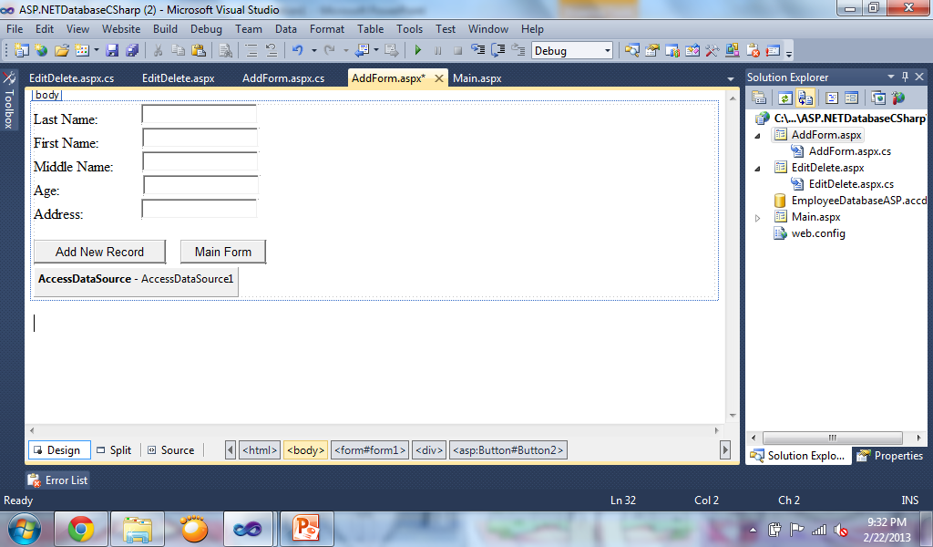

* Add a AccessDataSource Control to the Webform.
* Click on “Configure Data Source” to connect the AccessDataSource using the Connection Wizard.

**“Configure Data Source” Wizard**

* Browse the database you want to connect

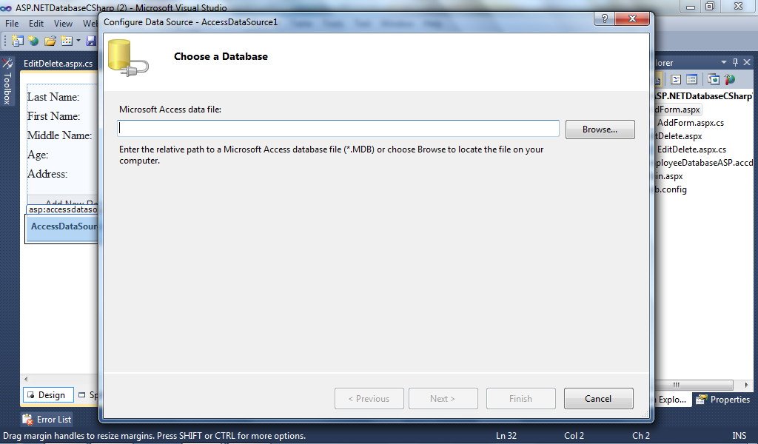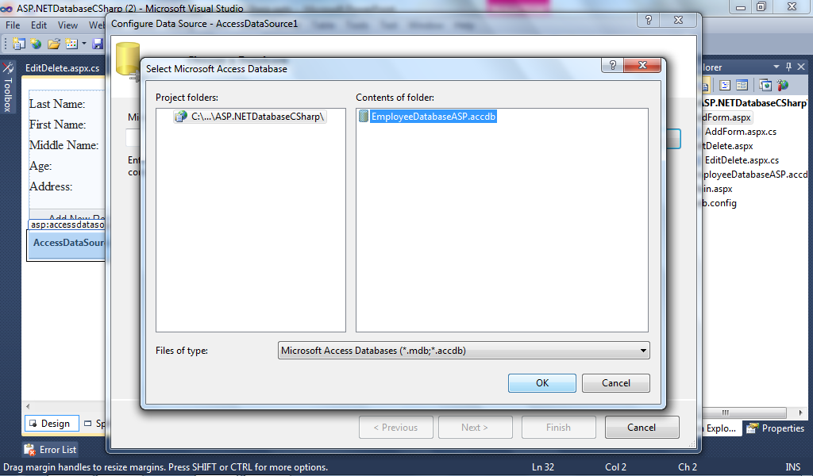

* Click next then choose “Specify columns from a table or view” then select the table name you want to connect

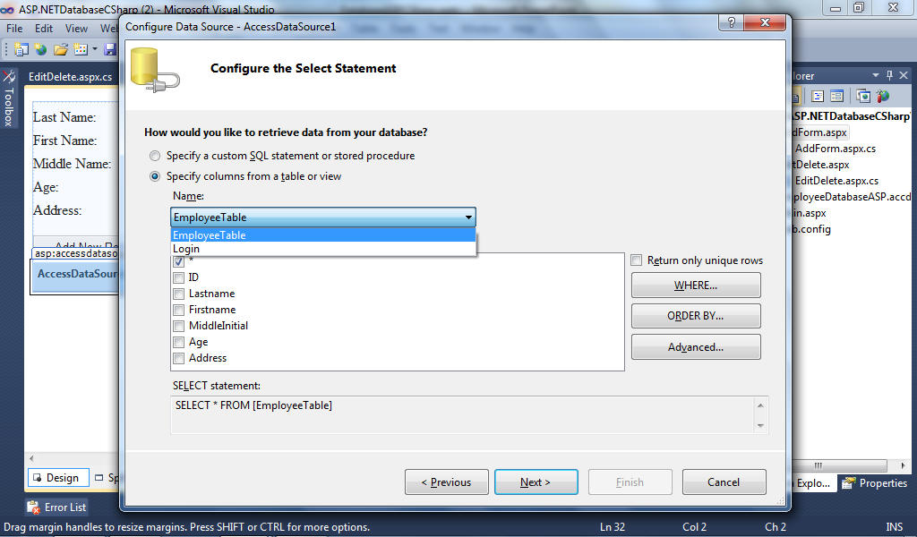

* Click on “Advanced” Button then Check “Generate INSERT, UPDATE, and DELETE statements

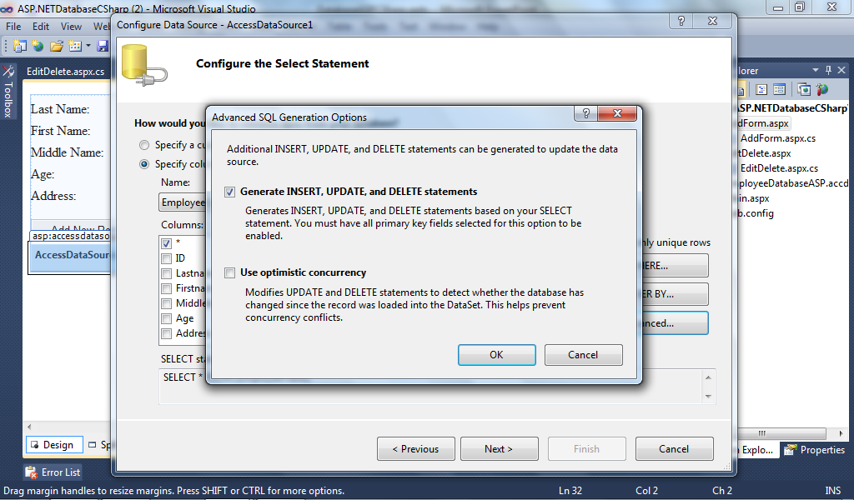

* Click “Next” then click “Test Query” to check the connection of the table then click “Finish”

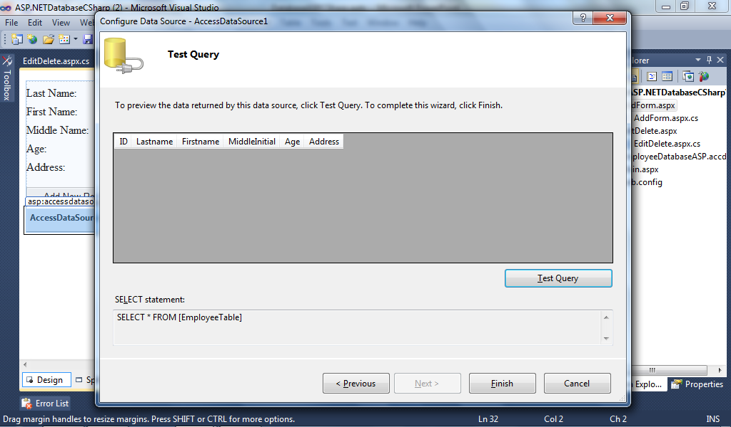

**Code for Adding Records using AccessDataSource**

If IsValid then

AccessDataSource1.InsertCommand = "INSERT INTO EmployeeTable (Lastname, Firstname, MiddleInitial, Age, Address) VALUES ('" + "Ramos" + "','" + TextBox2.Text + "','" + TextBox3.Text + "','" + TextBox4.Text + "','" + TextBox5.Text + "')"

AccessDataSource1.Insert()

End If

**Creating Edit / Delete Form**

* Insert GridView and AccessDataSource into the webform. Configure the datasource of the AccessDataSource. On the GridView, click “Choose Datasource” then select the AccessDataSource. Check “Enable Selection”.

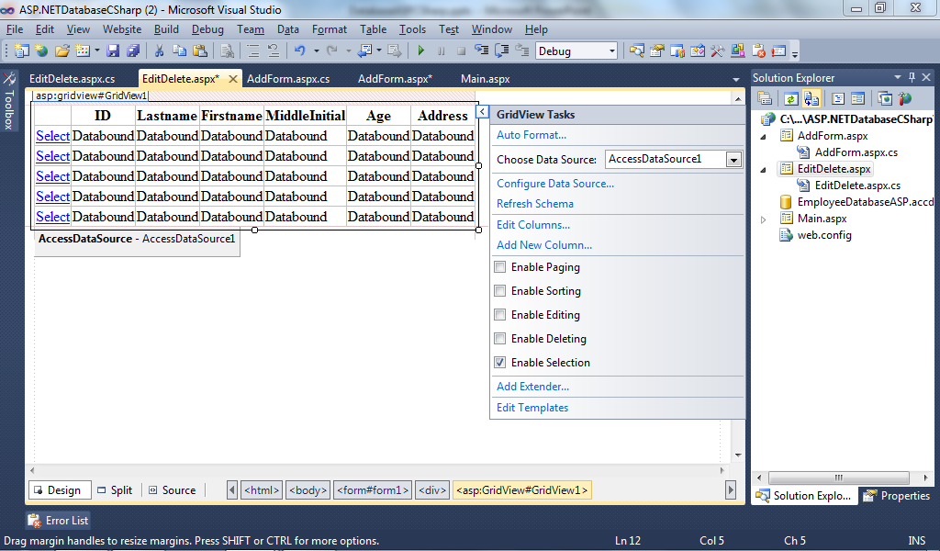

**Sample Form for Edit / Delete**

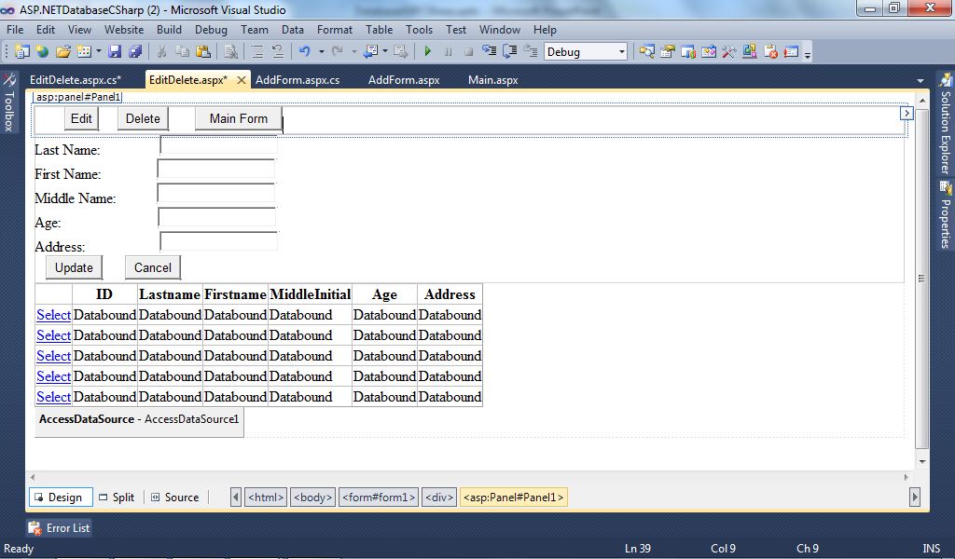

Panel 2

Panel 1

Pan

**Code for Edit Button**

Panel1.Visible = false

Panel2.Visible = true

**Code for Gridview_SelectedIndexChanged**

TextBox1.Text = GridView1.SelectedRow.Cells(1).Text

TextBox2.Text = GridView1.SelectedRow.Cells(2).Text

TextBox3.Text = GridView1.SelectedRow.Cells(3).Text

TextBox4.Text = GridView1.SelectedRow.Cells(4).Text

TextBox5.Text = GridView1.SelectedRow.Cells(5).Text

Session("ID") = GridView1.SelectedRow.Cells(6).Text

**Code for Delete Button**

try

AccessDataSource1.DeleteCommand = "DELETE FROM EmployeeTable " + "WHERE ID=" + Session["ID"].ToString()

AccessDataSource1.Delete()

catch (Exception ex)

End Try

**Code for Update Button**

try

AccessDataSource1.UpdateCommand = "UPDATE EmployeeTable " +

"SET Lastname ='" + TextBox1.Text + "'" +

", Firstname ='" + TextBox2.Text + "'" +

", MiddleInitial ='" + TextBox3.Text + "'" +

", Age ='" + TextBox4.Text + "'" +

", Address ='" + TextBox5.Text + "'" +

"WHERE ID =" + Session("ID").ToString + ""

AccessDataSource1.Update()

catch(Exception ex)

End Try

Panel2.Visible = false

Panel1.Visible = true

**Code for Cancel Button**

* Panel2.Visible = false
* Panel1.Visible = true

**Creating Login Form**

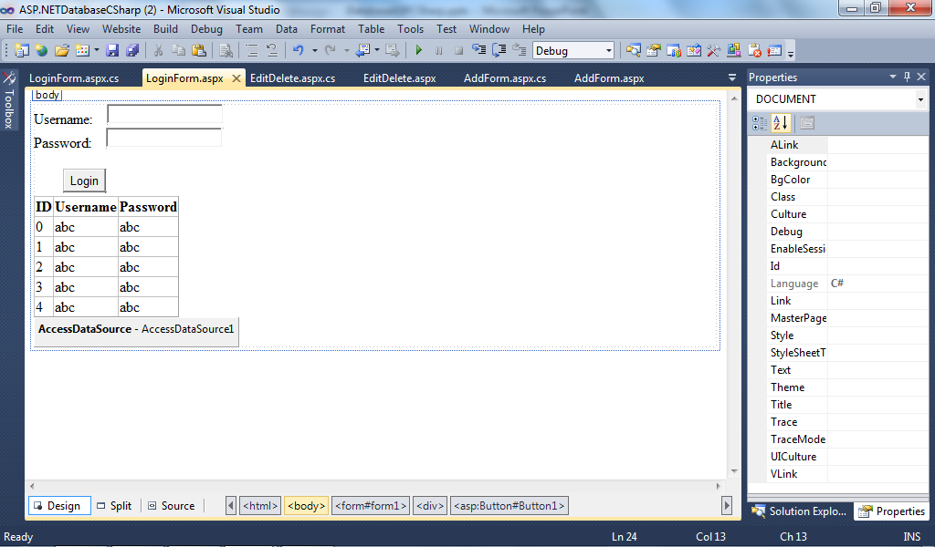

**Code for Login**

* If IsValid Then
* AccessDataSource1.SelectCommand = "SELECT * FROM Login where Username ='" + TextBox1.Text + "' and Password ='" + TextBox2.Text + "'"
* If GridView1.Rows.Count ==1
* Response.Redirect("Main.aspx")
* Else
* Response.Redirect("LoginForm.aspx")
* End If